U Query V Answer

**CS5551**

**Instructor: Dr. Yugyung Lee**  Syamala Reddy Arimanda

TA: Malathy Krishnan Swathi Boyanapalli

Vinod Kumar Vakalapudi

Rayan Katib Faruq

**Table of Contents**

|  |  |  |
| --- | --- | --- |
| **S.no** | **Description** | **Page No** |
| **1.** | **Project Deployment** | **3** |
| **2.** | **User Manual** | **4** |
| **3.** | **Project Management** | **6** |
| **4.** | **Project Proposal** | **7** |
| **5.** | **Project Plan** | **9** |
| **6.** | **First Increment** | **21** |
| **7.** | **Challenge1** | **34** |
| **8.** | **Challenge2** | **41** |
| **9.** | **Second Increment** | **56** |
| **10.** | **Challenge3** | **73** |
| **11.** | **Third Increment** | **78** |
| **12** | **Presentation Materials and Project Evaluation** | **98** |

**PROJECT DEPLOYMENT**

The entire code of implementation has been completed and deployed in GitHub. The GitHub link is provided below:

<https://github.com/syamalareddy/final_doc/blob/master/Final%20Documentation.docx>

The project description and methodologies are described briefly and are captured as a video. The video has been uploaded to the YouTube which can be viewed using the following link:

<https://www.youtube.com/watch?v=oLQy4m58o-k>

Our project has been planned using the Scrum do which is an agile tool and the link is given below as follows:

<https://www.scrumdo.com/organization/u-query-v-answer/projects>

**USER MANUAL**

**GitHub Project URL:**

https://github.com/syamalareddy/final_doc/blob/master/Final%20Documentation.docx

**1. Introduction:**

*U Query V Answer* is an online based application that provides service to the students in order to plan their higher studies. This application acts as a bridge between the students and the exam conducting departments in scheduling and taking various examinations. It allows the students to select any particular topic that is available and can prepare for the examination. The students will be able to use the various services provided by the different publishers.

**2. How to use the system:**

Our system supports only mobile version and any student (or) user can access our system by registering and logging in for free.

**2.1. How to access the system:**

The student will be directed to our home page “U Query V Answer” upon opening our application. In the home screen student can find “Sign-up, and “Login” tabs on the top of the screen with some rich user interface design. We have also provided with “Contact us” in order to reach us for posing different types of queries.

**2.2. Sign up and Login:**

Our application will provide sign up form for students. New students or users can fill their details and submit the forms to the system. If the user-entered details don’t meet any requirements it will prompt an error message, otherwise it will display successful registration upon clicking submit button in the sign up form. Existing students can use their credentials to login to the application. Upon successful login the students will be redirected to the home page of our application.

**2.3 Contact Us:**

On the top of the home page we have provided contact us tab. If any student wants to contact the system administrator they can leave a message to him/her by submitting the form in “contact us” page.

**2.4 Student Screens:**

After successful registration student can see “three different services”. They are GRE, TOEFL and LIST OF UNIVERSITIES.

**Services:** This list of services “U Query V Answer” system can serve is as follows. For example GRE, TOEFL, List of Universities. By selecting services like GRE and TOEFL system will display the pattern of the particular examination, sample papers and mock tests. By clicking List of Universities it will display the university details for a particular score in a particular examination.

**2.5 GRE:**

By clicking the GRE, we are having the options like gre pattern, gre sample papers, and mock tests of gre examination. GRE pattern deals with the entire pattern of the examination along with the timings and also different sections of questions that are given in the examination. GRE sample papers have different sections of questions like analytical writing, verbal reasoning and quantitative reasoning. Mock tests deals with the entire package of the Gre examination and after completion of the exam it gives the feedback to the student.

**2.6 TOEFL:**

By clicking the TOEFL, we are having the options like toefl pattern, toefl sample papers, and mock tests of toefl examination. TOEFL pattern deals with the entire pattern of the examination along with the timings and also different sections of questions that are given in the examination. TOEFL sample papers have different types of topics like listening, reading, speaking and writing. Mock tests deals with the entire package of the TOEFL examination and after completion of the exam it gives the feedback to the student.

**2.7 List of Universities:**

By selecting the list of universities we are having the options like universities with GRE scores and universities with TOEFL scores. In each section we have number of universities listed for different scores.

**2.8 Logout:**

Users can logout from the system using “Logout” tab.

**2.9 Mail Implementation:**

A mail will be generated and sent by our application “U Query V Answer” to the students after posting their queries or doubts.

**PROJECT MANAGEMENT**

As part of our Project Management, We had used Scrum Do Website for planning our tasks among our team mates.

1. Syamala Reddy Arimanda
2. Swathi Boyanapalli
3. Vinod Kumar Vakalapudi
4. Rayan Faruq Katib

<https://www.scrumdo.com/organization/u-query-v-answer/projects>

<https://www.scrumdo.com/projects/project/increment-1/summary>

**PROJECT PROPOSAL**

**PROJECT GOAL AND OBJECTIVES**

**Motivation:**

From last 5 years, the mobile devices are available for every human in the world where we had experienced a lot of innovation in the areas of Education. Every student needs some or the other information regarding their college, it takes a lot of time to have the information from the university website. We are motivated to make their task easy and more entertaining with the present day technology like Android Mobile device application.

**Significance:**

Our project will give a clear idea about many things that are necessary to a student at the time of choosing a school to attend and also after attending the school. Our project has many answers to various types of questions that were really necessary and helpful to the students at the selection process of a school. We divide various questions into some groups.

Example: Admission Procedure is a group in which it can answer many questions like

1. What are the steps to be followed to apply to the school?

Ans: student should have gre, toefl/ ielts score card, transcripts, sop, lor etc.

2. What are the required scores that are mandatory to apply?

Ans: gre: 300+ particularly having quant score more than 160.

Toefl of minimum 100 or ielts of minimum 6.5

3. Is the school accepts ielts score less than 6.5?

Ans: Yes, the school will also accept the score of 6 but student must have to attend a test i.e. ALI.

**Objectives:**

* Our project completely provides the details of the various topics which are covered in various examinations.
* Our project helps the students to have all the details about the admission procedure. All the required marks in the competitive exams like gre and toefl and the required GPA to get the admission in the school.
* In order to know the status of the application the student can track the status of their application by the identification number that was provided by the school.
* A student can also have the possibility to know whether he is eligible for the scholarship/funding and also the requirements for getting a scholarship.

**System Features:**

Generally the school details are available in various sites in the internet but it is difficult and also time-being process to a student to go through all the sites. In order to make this task easy we are doing this project and in this we have all type of answers for various questions. If a particular student needs more information which is not available in the site, the student also have the possibility to pose questions and our team will respond for the questions as soon as possible.

**Technical and Architectural Requirements:**

* User interface(Web Frame): HTML

CSS

Java Script

PHP

* Back End: UMKC Website

* Web Services: Android Development kit , Microsoft Visual Studio

UMKC Server

* UML /Architecture Diagrams: Microsoft Visio 2013
* Planning: Scrumdo

**Related Work:**

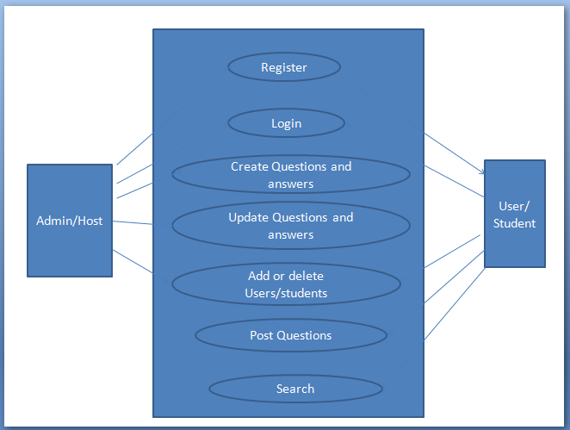

**Use Case Diagram**

**Bibliography:**

<http://www.umkc.edu/>

<http://en.wikipedia.org/wiki/PHP>

**PROJECT PLAN**

**I. INTRODUCTION**

“U Query V Answer” is an online based application that provides service to the students in order to plan their bright future. This application acts as a guide for the students in attending and achieving success in various exams and cope up with their grades or GPA. This application acts like an encyclopedia and allows the student to select a topic that is available and will give fetch the data giving an idea about the topic clearly along with the examples in various formats. Thus, making the student ready to face any kind of interview or examination and help them to achieve their goals and help them achieve success.

**II. PROJECT GOAL AND OBJECTIVES (REVISED)**

**Overall goal:**

Our project gives clear idea about many things that are necessary for a student at the time of choosing a school to pursue his degree and also after attending the school. We have many features in our project which provides many answers to various types of questions that were really necessary and helpful to the students at the selection process of a school. We divide various questions into some groups.

Example: Admission Procedure is a group in which it can answer many questions like

1. What are the steps to be followed to apply to the school?

Ans: student should have gre, toefl/ ielts score card, transcripts, sop, lor etc.

2. What are the required scores that are mandatory to apply?

Ans: gre 300+ particularly having quant score more than 160 and Toefl with a score of 100 minimum or ielts with minimum of 6.5

3. Is the school accepts ielts score less than 6.5?

Ans: Yes, the school will also accepts the score of 6 but student must have to attend a test i.e., ALI.

Once the student decides his school then he will be provided with model test papers of both the gre and toefl/ielts exams with all the sections covered in it.

Example: We provide sections like quant, verbal, analytical writing under gre exam and sections like speaking, listening, writing and reading under toefl exam.

**Specific objectives (problem statement):**

All the sites in the internet will have their own questions for different topics that are necessary for attending an exam or an interview, but it is very difficult to access all the sites and the topics to prepare from. Even knowing & choosing the sites in the proximity is also tough. It is also tough to compare two sites and the different models and various levels of questions in it. Thus, our project makes the search easy.

**Significance:**

1. Our project completely provides the details of the various questions, models that were focused in the entrance examination.
2. Our project helps the students to have all the details about the admission procedure. All the required marks in the competitive exams like gre and toefl and the required GPA to get the admission in the school.
3. The student can track the status of their application by the identification number that was provided by the school.
4. A student can also have the possibility to know whether he is eligible for the scholarship/funding and also the requirements for getting a scholarship.
5. Students are provided with all the required material i.e., model questions for the competitive exams like gre and toefl which are essential for a student admission.

**III. PROJECT BACKGROUND AND RELATED WORK**

We find a number of websites having their own online guides for preparing and achieving in various exams or interviews service like<http://www.majortests.com>. In this portal, the students have the facility to search for a particular exam, topic, various sections and levels in it. Currently, we find no such online service providing these services. Our project will be solution for this.

**IV. PROPOSED SYSTEM**

**1) Requirement Specification:**

**Functional Requirements (Prioritized):**

* Users can register with their details, login and then update their profile if required.
* Students can choose the required exam and under that the required category in the website.
* Every detail is provided to the students about the universities.
* Statistics are provided to the students at different categories of exams like gre and toefl.

**Non-Functional Requirements:**

* Our online service will be student friendly and easy to use.
* available on every day i.e., 24*7
* Loading our mobile application is fast as it uses very less bandwidth.

**Business Process/Workflow analysis:**

* Students register and get login with their credentials.
* After choosing the particular university in the catalogue they can check for the required cutoff for exams like gre, toefl etc.
* If the student selects the university, he/she can get entire details about that particular university.
* Student can select the practice tests and can access their level through the feedback.
* They can retake the particular section to improve their marks in particular section for free.

**Technological and Architectural requirements:**

1. User interface (Web Frame):

* HTML
* CSS
* Java Script
* .NET
* PHP

2. Back End: ETS Website

3. Web Services:

* Microsoft Visual Studio 2010 ( C#)
* Android Development Kit
* Mash up
* UMKC Server

4. Testing: NUnit

5. UML /Architecture Diagrams: Microsoft Visio 2013

6. Planning: Scrumdo

7. Databases: SQL Server

**2) Framework Specification: Build an overall system model:**

**Methodologies and Algorithms**

Our project requires changes very frequently. So in order to make our application more creative we use Scrum which is an important agile methodology.

**System Architecture Diagram:**

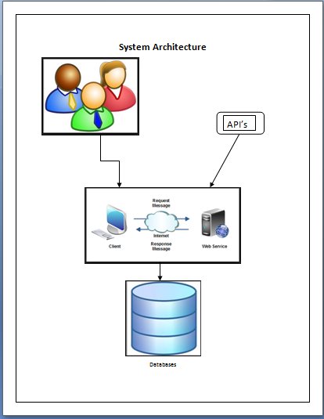

**3) System Specification:**

**Services to be implemented:**

|  |  |  |  |
| --- | --- | --- | --- |
| S.No | Name | Description | URL |
| 1. | Google Maps | To have the geolocation of the school | <https://maps.googleapis.com/maps/api/directions/output?parameters> |
| 2. | Google Search Engine | To search the required information for the student | https://ajax.googleapis.com/ajax/services/searc  h/web?v=1.0&q= |

**New Services to be built:**

Login: To authenticate the student and the admin login.

Update-User: To update the user profile.

Update-Database:To update the exams and the feedback to provided to the user.

Retrieve:We get the data according to the users search criteria.

**Use Case Diagram:**

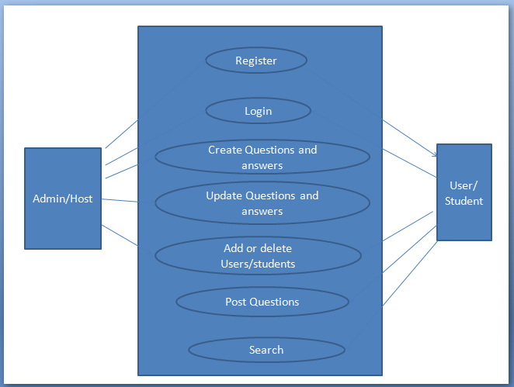

**Activity Diagram**

Admin activity:

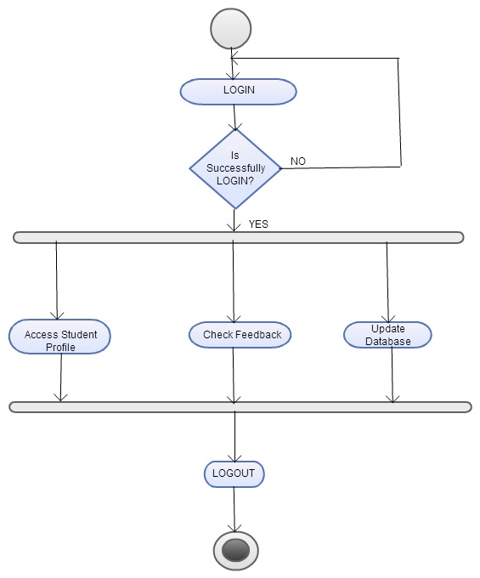

**Student Activity:**

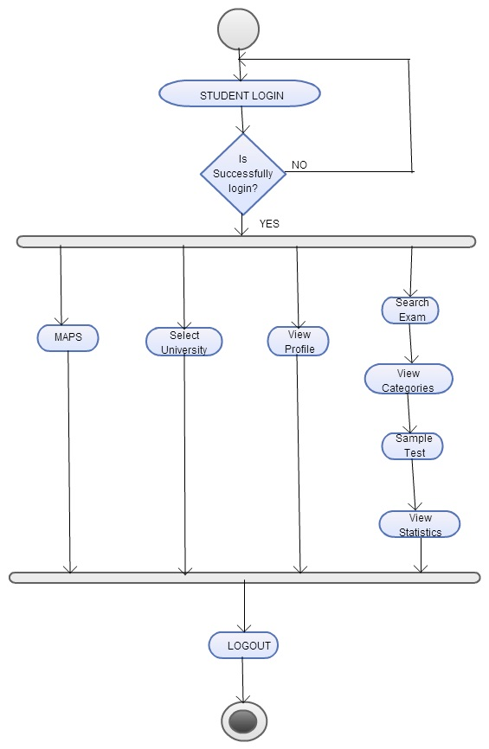

**Service Specification:**

* Operational description

Students login for the web application updates their profile, assess their skills using practice tests etc. where the admin login to update the database, view students profile etc.

* Input/output for services

Input will be the data entered by the user to search for a school and output will be the tests and the suggestions given to students.

* Design of Mobile Client

Students can update their information and select universities based on their range and can prepare for the tests through practice tests whereas admin can update the database.

* Features, Styles, Technologies

JAVA, C#, ASP.NET, SOAP Web Services

**V. RISK MANAGEMENT**

* Services need to be fast and reliable
* Everything need to be updated i.e., the databases should be updated based on the students choice.
* All the information should be compatible on both the phone and the website.
* Multiple transactions and parallel applications must be carried out.

**VI. PLANNING: SCRUMDO**

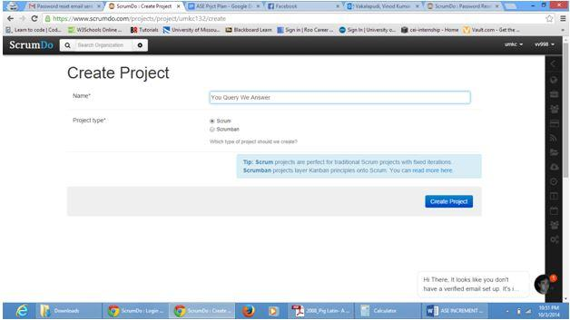

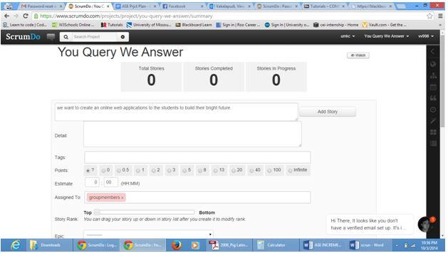

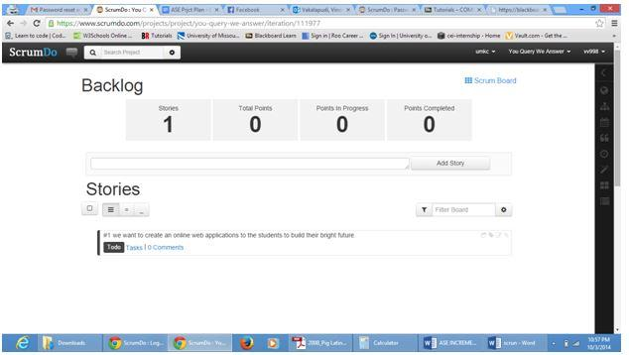

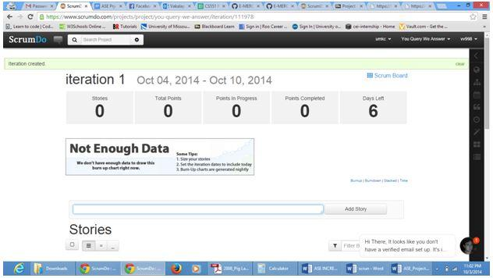

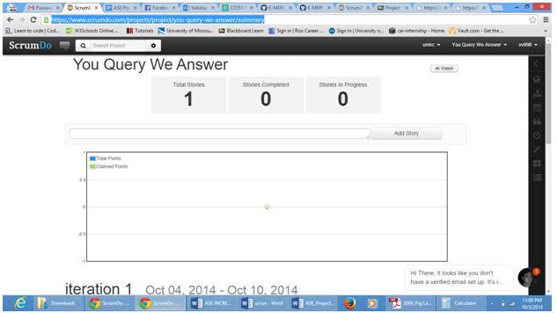

Scrumdo URL: <https://www.scrumdo.com/projects/project/you-query-we-answer/summary>

**VII. BIBLIOGRAPHY**

[www.google.com](http://www.google.com)

<http://msdn.microsoft.com/en-us/vstudio/aa718325.aspx>

<http://www.w3schools.com/>

<http://msdn.microsoft.com/en-us/library/vstudio/4w3ex9c2(v=vs.100).aspx>

**PROJECT INCREMENT 1**

**Introduction:**

Planning for higher studies is a great step for having a bright future and is on high demand. To plan for higher studies, you need to go for required exams, for this a good preparation is necessary, this can be done by preparing a good book or having a good website in which one can find many different and difficult concepts that are required to the exam. Later they have to login for different websites and search for the required course material. Also, it will be difficult to search for different websites and patterns of questions as each website has their own in built course material. To avoid these problems, our project acts as a single stop where a student can find different materials in one place with a common user interface (UI) in his palm as it was an android application. This project provides feasibility to prepare for the exams both through mobile and web applications. In this application, students can take advantage by getting good course material easily.

**System Architecture:**



**Use Case Diagram:**



**Work Completed till 1st Increment:**

We have created the user interface for student registration through signup page, login authentication and profile updates. Same functionality pages were implemented even in android.

**Implementation Status Report:**

**Work Completed:**

Database plays a major role in our project. So, for the first increment we have created some tables in the database. The tables which we have created were:

· Student details

**Student Details Table:**

In this table we have attributes like student name or the username, password, phone number, country name, state name/province, district, city/county/area.

**Screen Shots:**

We have created the below web page with all the services enlisted in the right side of the web page. User when clicked on the start your preparation button which is redirected to the services page.

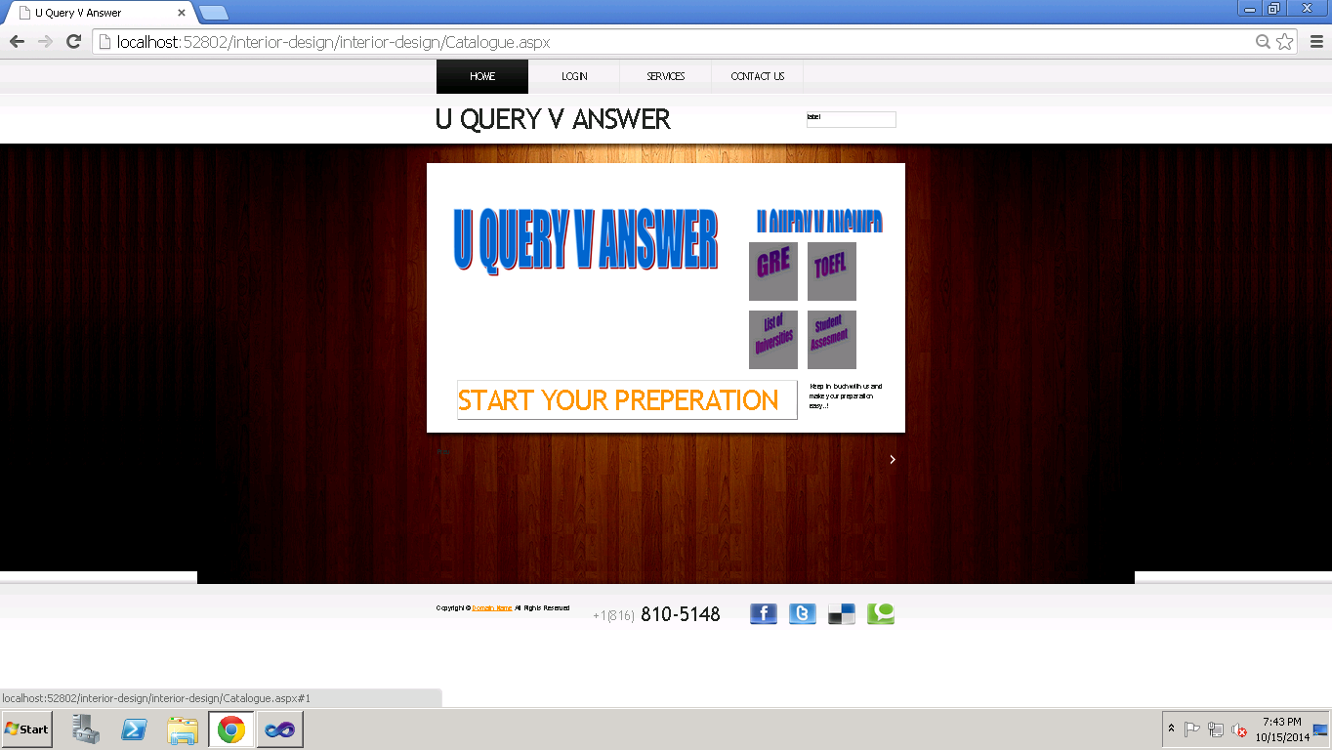

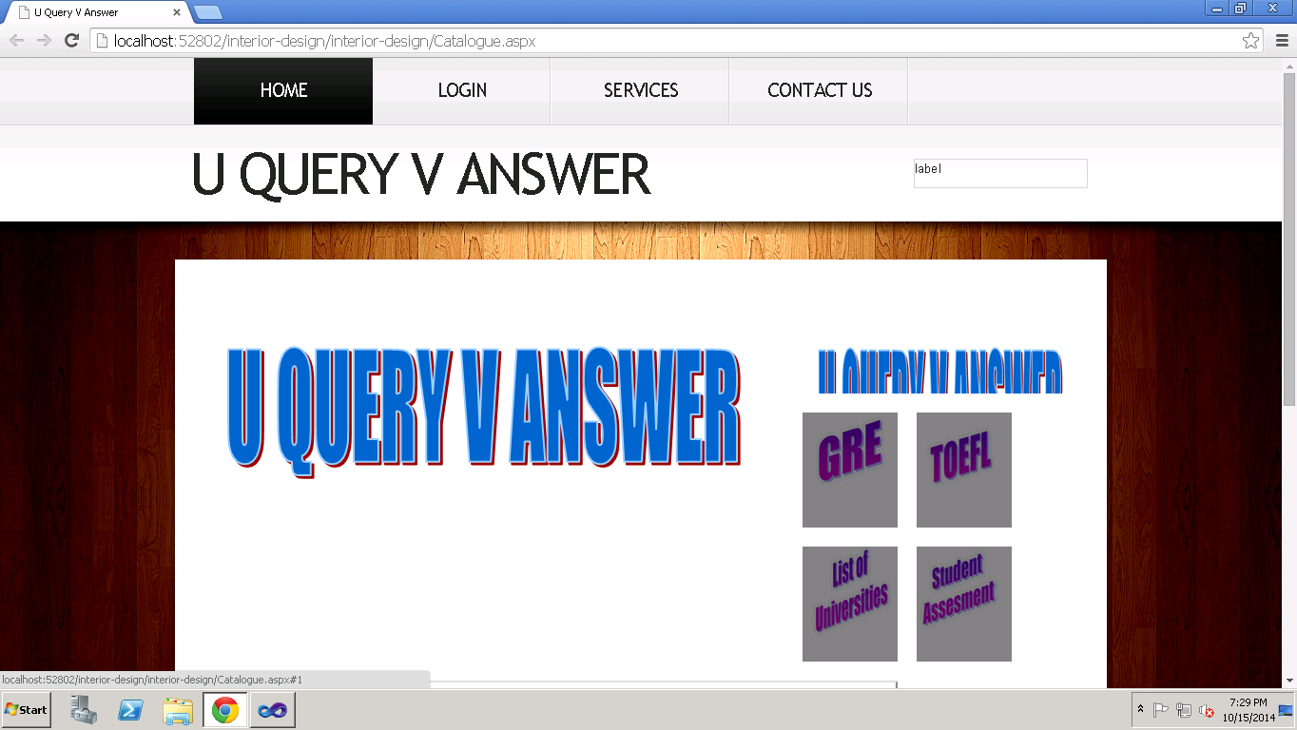

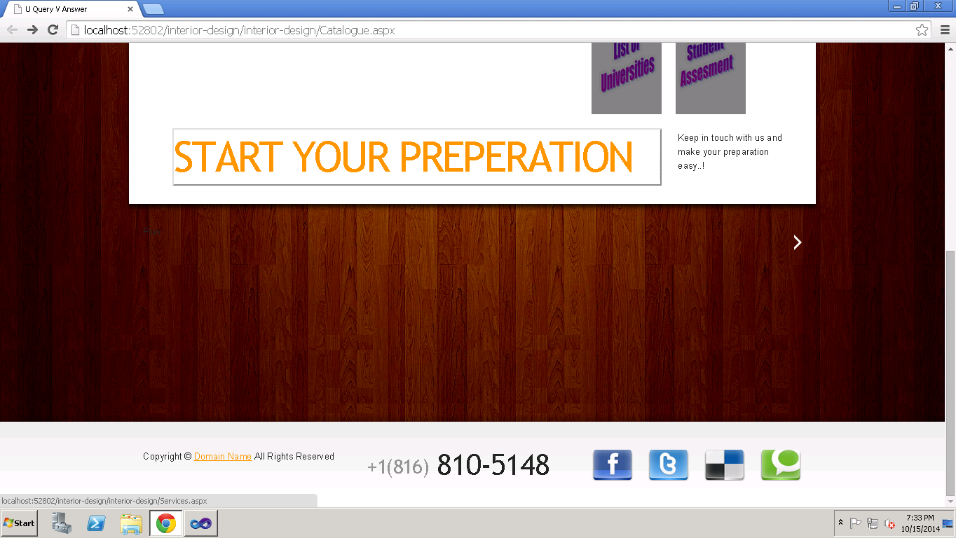

The below shown are the screenshots of the services page. We have the list of universities, gre, toefl mock tests and the assessments of the students are provided.

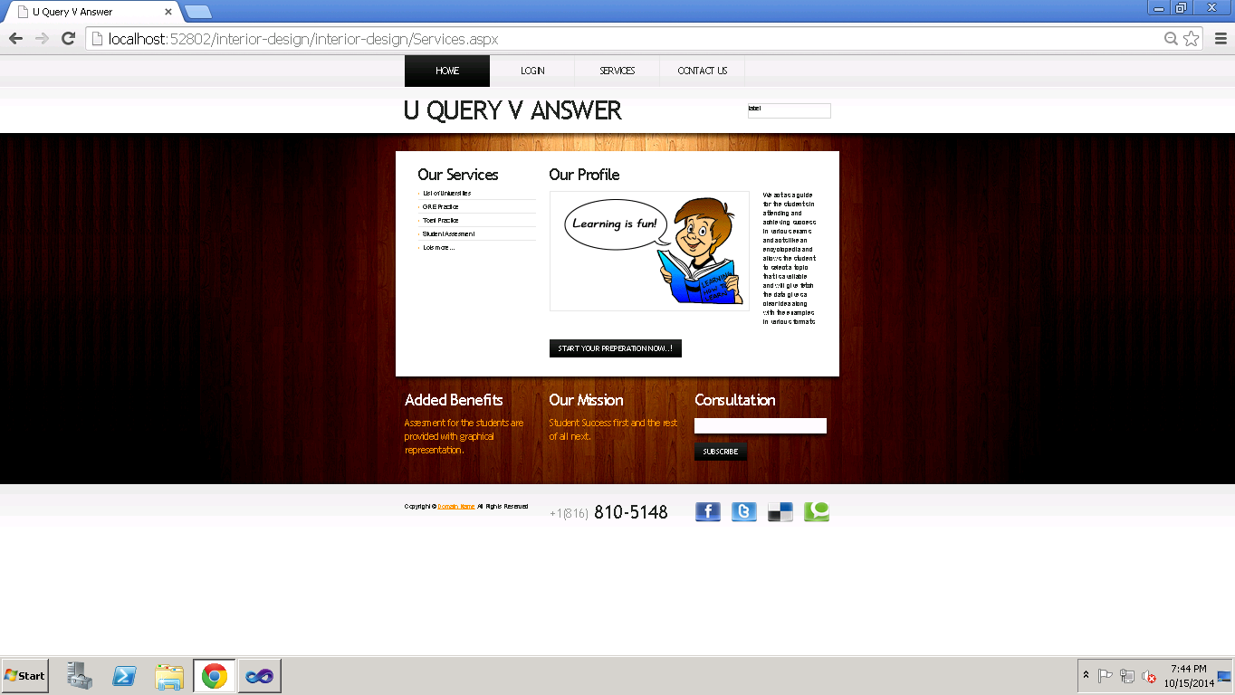

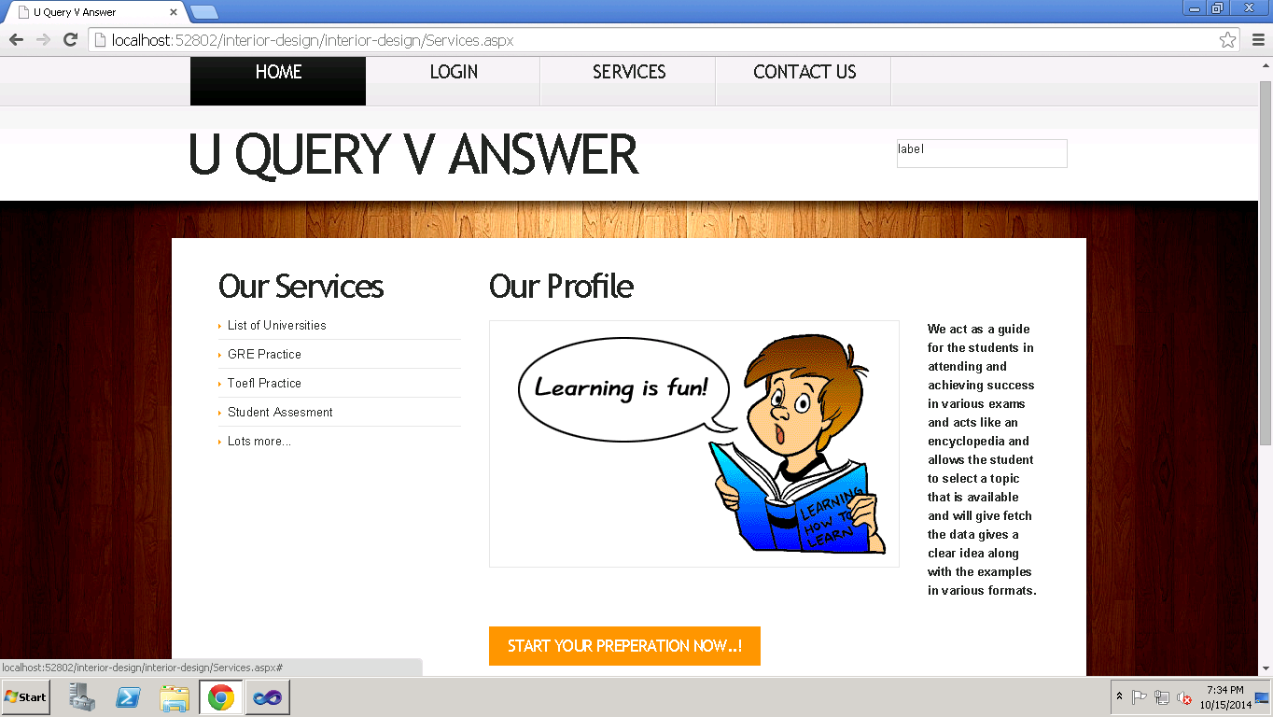

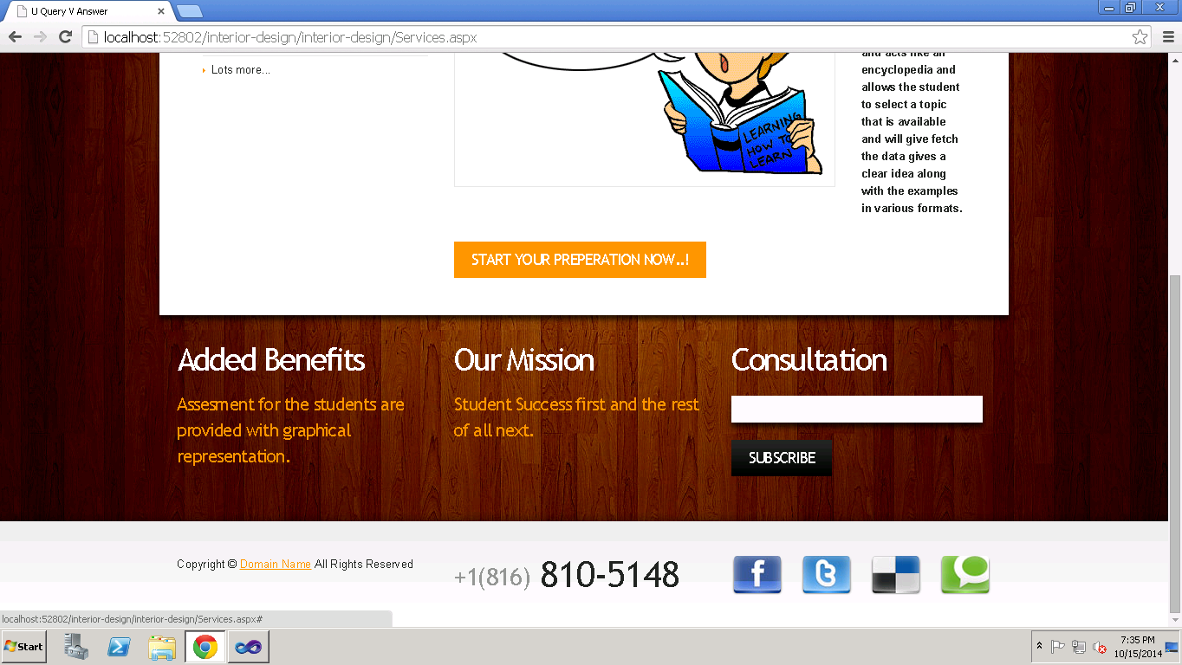

Student selects a particular service under the services provided and then he is directed to the login page where the student is registered. The credentials are given and then login, the screenshot is shown below.

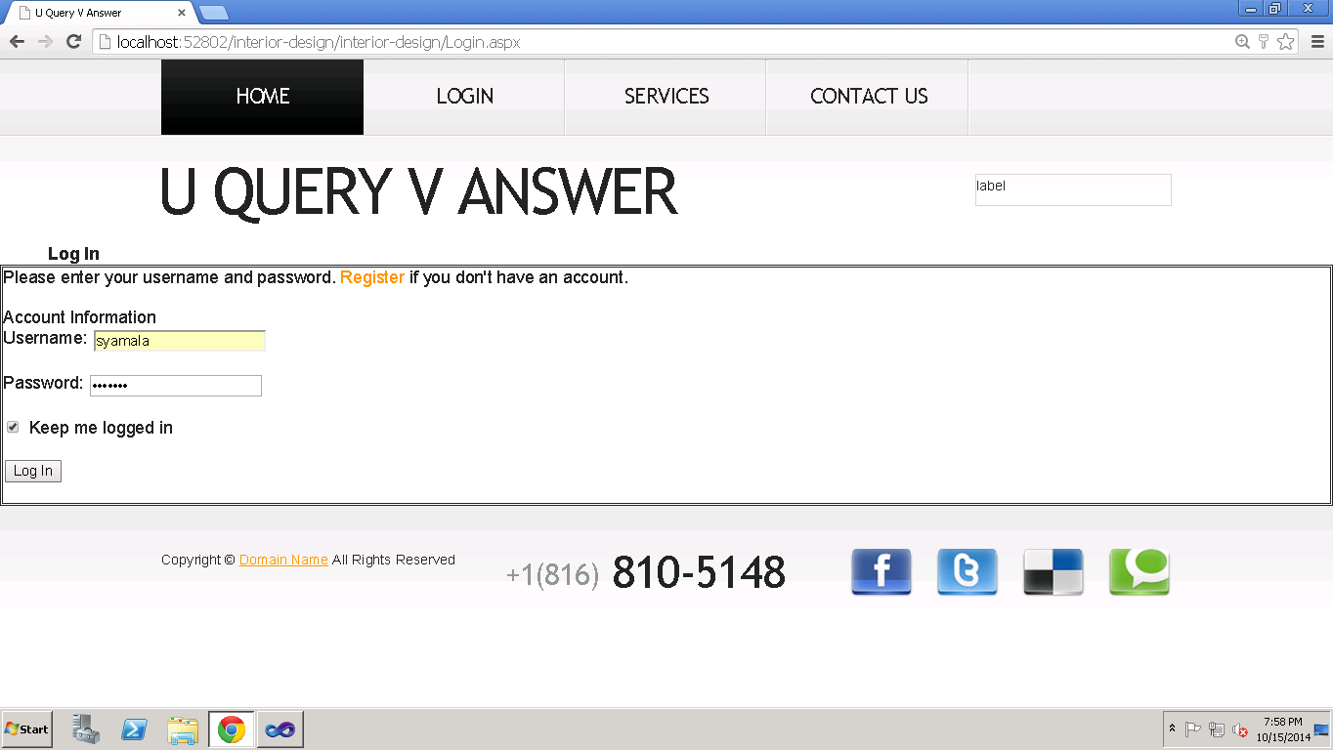

In the Contact form shown below, the users can submit their message and can send for the admin.

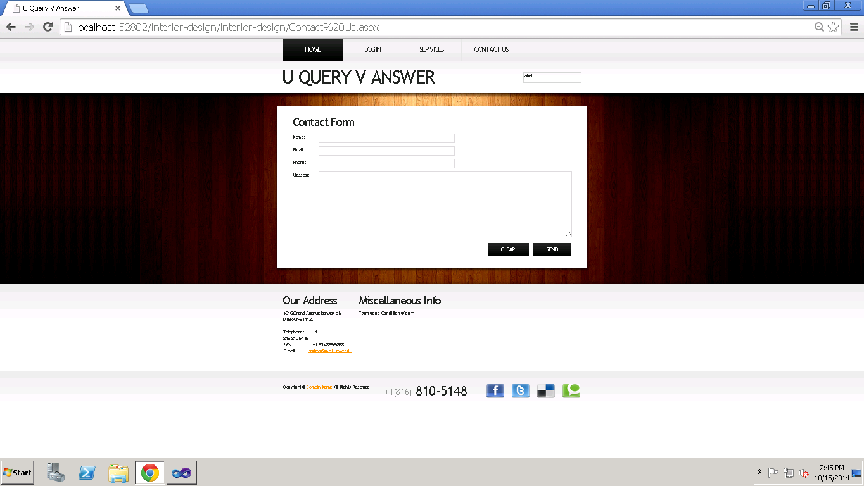

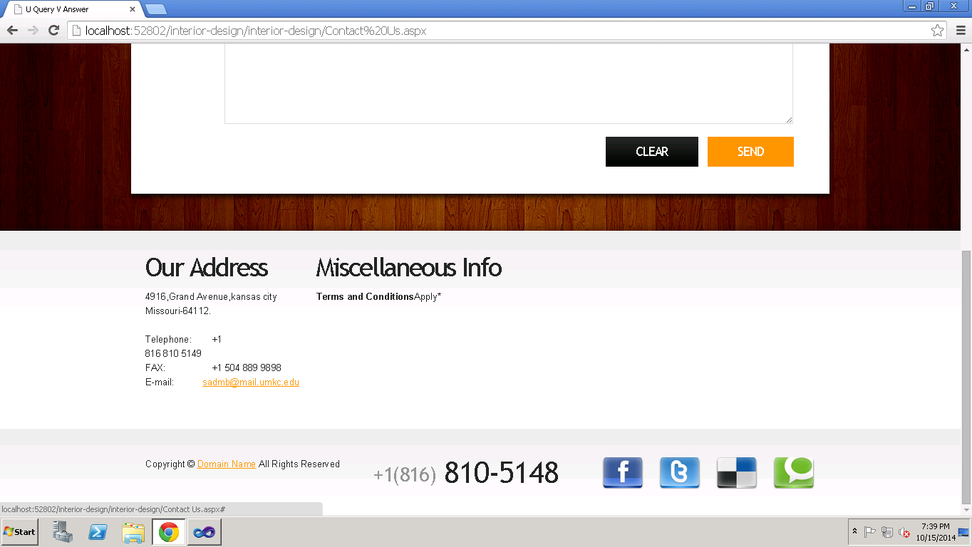

Along with the web pages we have created android pages too and the concerned screenshots are shown below.

**Screen shots of our android application:**

The below screenshot shows the sign in page when we click U Query V Answer icon in the apps menu.

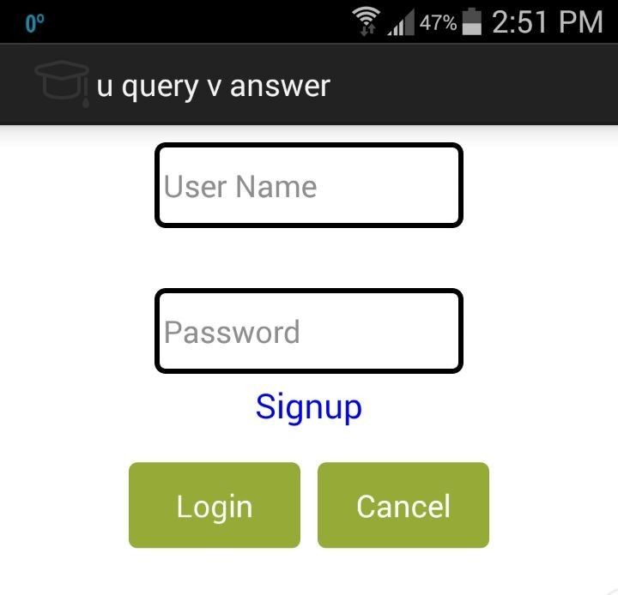

New student or user can give all the required credentials and then make him/her login into the application.

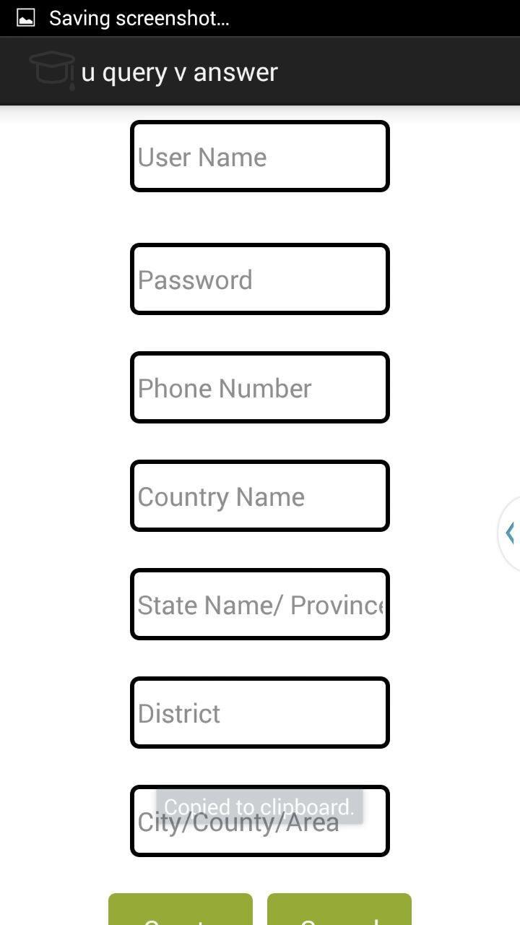

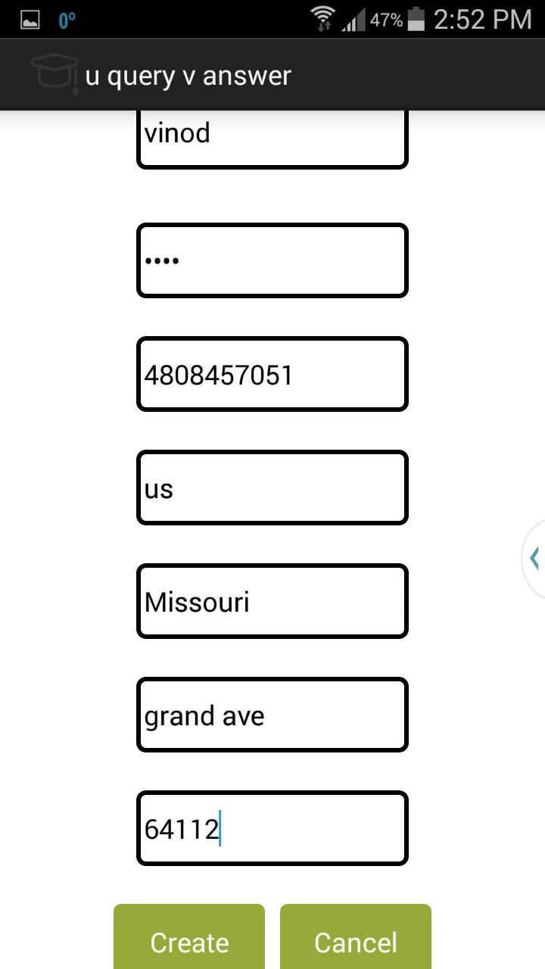

Above screenshot shows the example of student who gets logged in by giving his name, password ,phone number ,country, state, address, country code and then click the create button.

Then the page gets redirected to the home page of our android application as shown below.

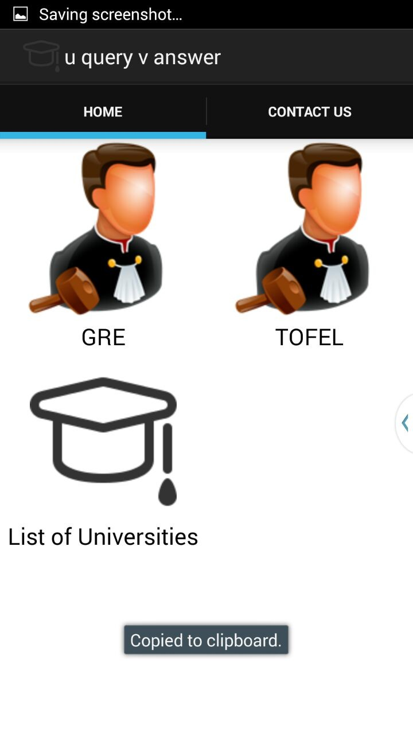

**Screen shot of our home page**

We provided the student with the gre, toefl and the list of universities icons and a detailed description and the services are provided along with screenshots in the next increment.

**Responsibilities:**

|  |  |  |  |
| --- | --- | --- | --- |
| **Sl.No** | **Task** | **Person involved** | **Estimated Time** |
| 1. | Designing of User Interface for both web and android application | Syamala  Swathi | 4 hr |
| 2. | Creating Database and connecting this using sql management studio to store student and publisher details | Swathi  Syamala  Vinod | 2 hr |
| 3. | Creating tables to store student details | Rayan | 2hr |
| 4. | Creating sessions to maintain the login details | Syamala  Swathi  Vinod | 2hr |
| 5. | Creating tables to store publisher details | Swathi | 2hr |
| 6. | Connecting API services | Syamala | 2 hr |
| 7. | Creating android login and home pages | Rayan | 2hr |
| 8. | Testing the project | Syamala  Swathi  Vinod | 2hr |

**Work To Be Completed As Part Of 2nd Increment:**

We will implement the web services in second increment and link those services to the database for the search engine and then create a webpage to display the search results.

**Responsibilities:**

|  |  |  |
| --- | --- | --- |
| **Sl.No** | **Task** | **Person involved** |
| 1. | Have to create web services for google and facebook | Syamala  Swathi  Vinod  Rayan |
| 2. | To create web services for searching the publisher | Swathi  Syamala  Rayan  Vinod |
| 3. | To implement web services on android. | Syamala  Swathi  Vinod  Rayan |
| 4. | To Test the web services by using Nunit testing | Syamala  Swathi  Vinod  Rayan |
| 6. | Documentation work | Swathi  Syamala  Rayan  Vinod |

Screenshots of Scrum Do:

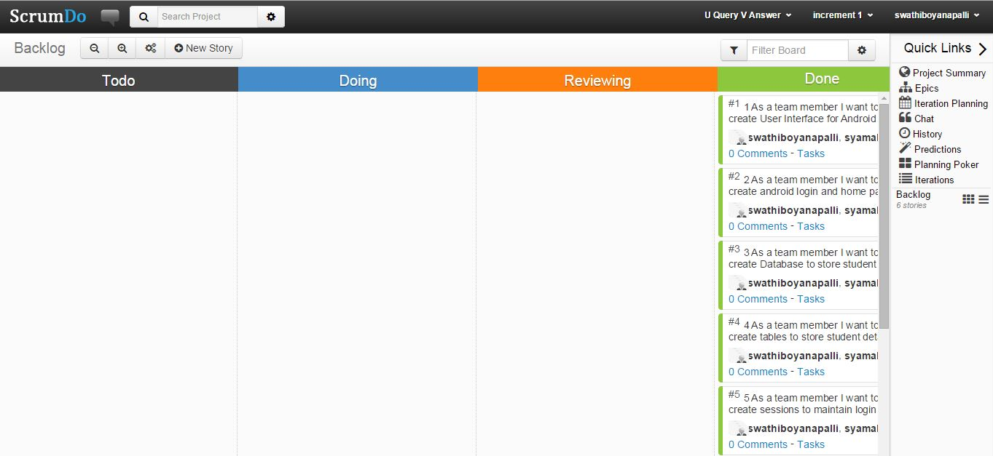

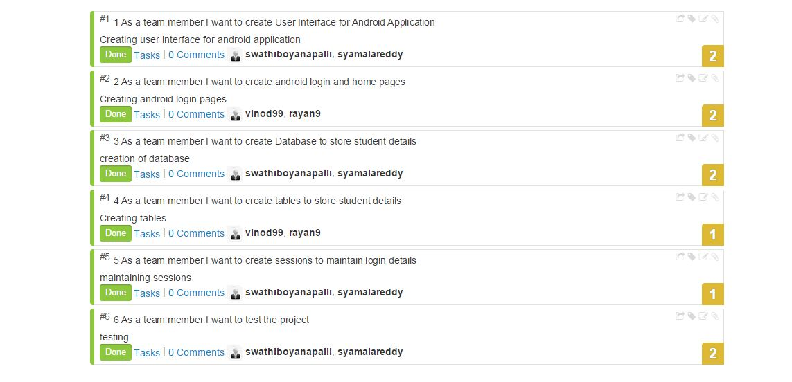

**CHALLENGE 1**

**Syamala Reddy Arimanda – 02**

**Swathi Boyanapalli – 10**

**1. Design:**

1. **Architecture Diagram:**



1. **Class Diagram:**



**2. Features Implemented:**

* Home Page
* Services Page
* Login Page
* Register Page
* Pricing Page
* Shopping Cart Page

**3. Tools Used:**

1. **Database:**

We have used “MSSQL Server Database” for our application to store groceries data like Item_Id, Item_Name, Item_Cost, Item_Image etc.

1. **Tools:** Microsoft Visual Studio 2010,HTML 5, C# .NET

**3. Screenshots of Grocery Finder:**

The following screenshot is our application home page.

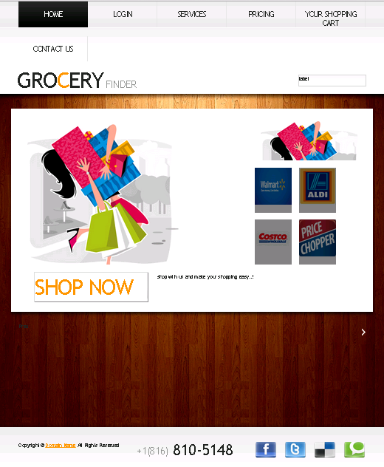

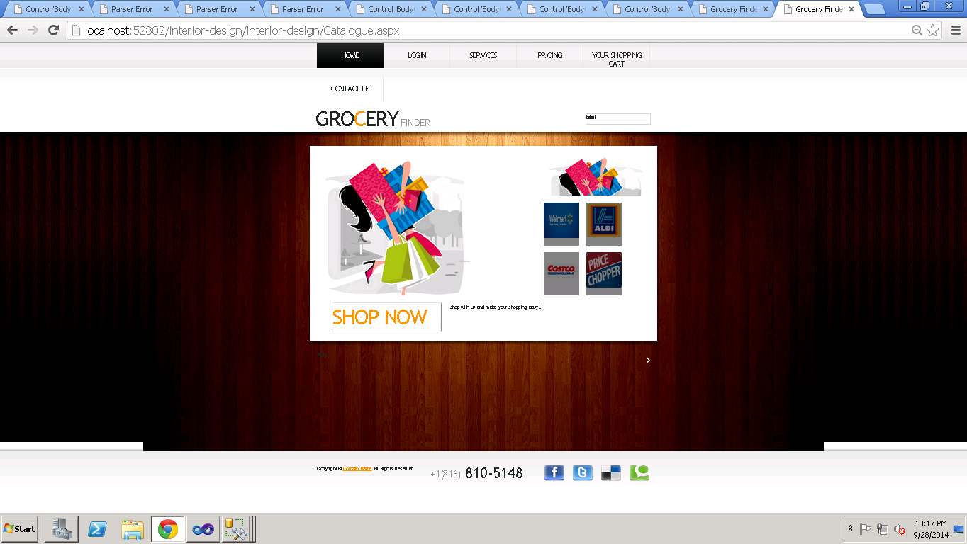

If we click the shop now button, this page gets redirected to the services page where we can find the store names.

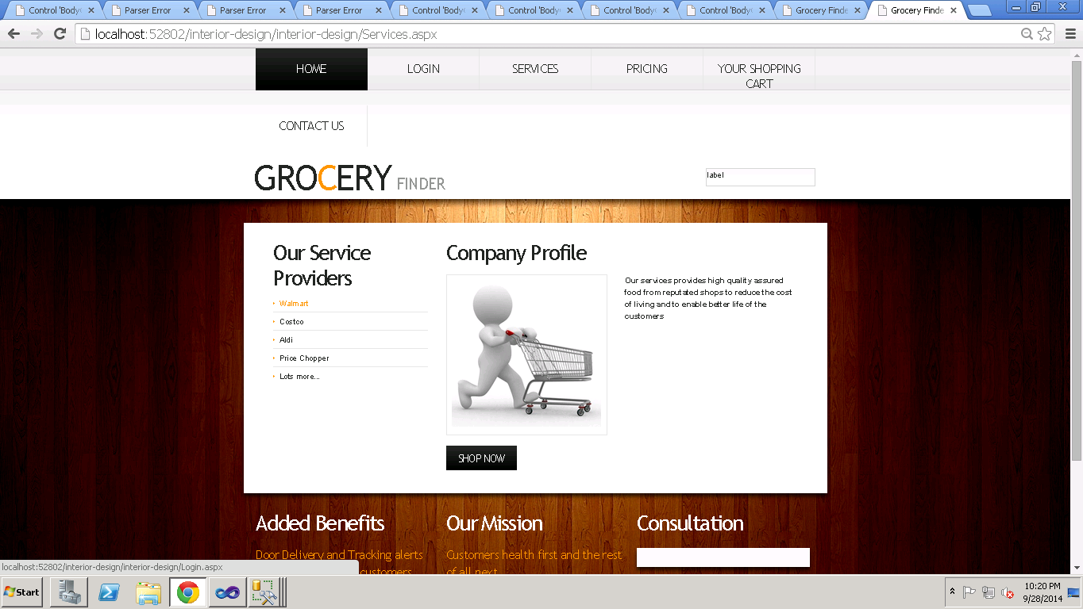

Upon selecting the shop by the user choice it gets redirected to the login page where the user gives his credentials as shown below.

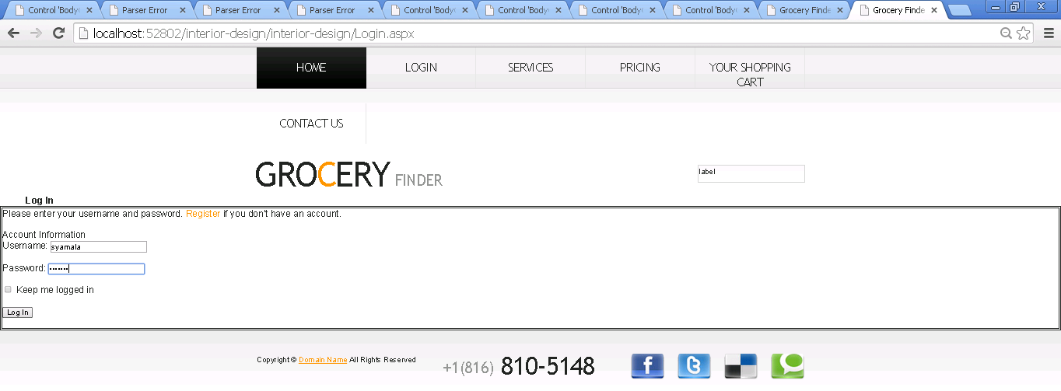

An icon is displayed at the top right corner of the page and is redirected to the items list page.

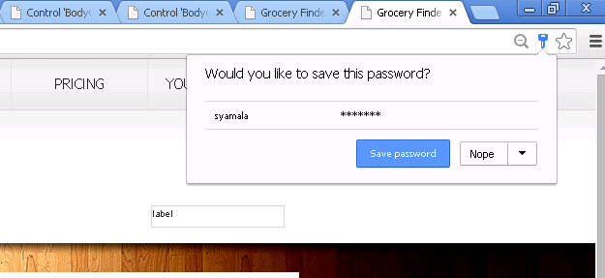

By registering the users gets a chance of adding their choice of items to the shopping cart and he can proceed for checkout.

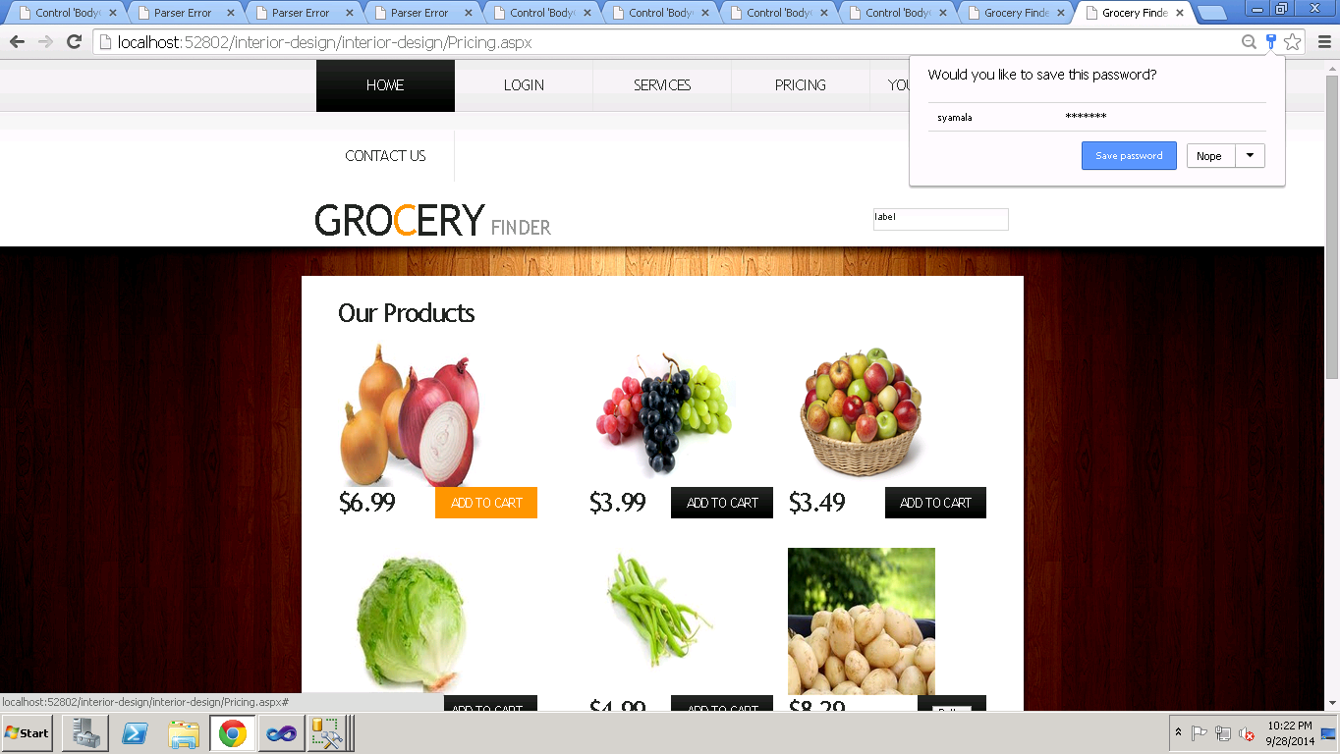

We have a special feature of giving feedback to the users for their suggestions.

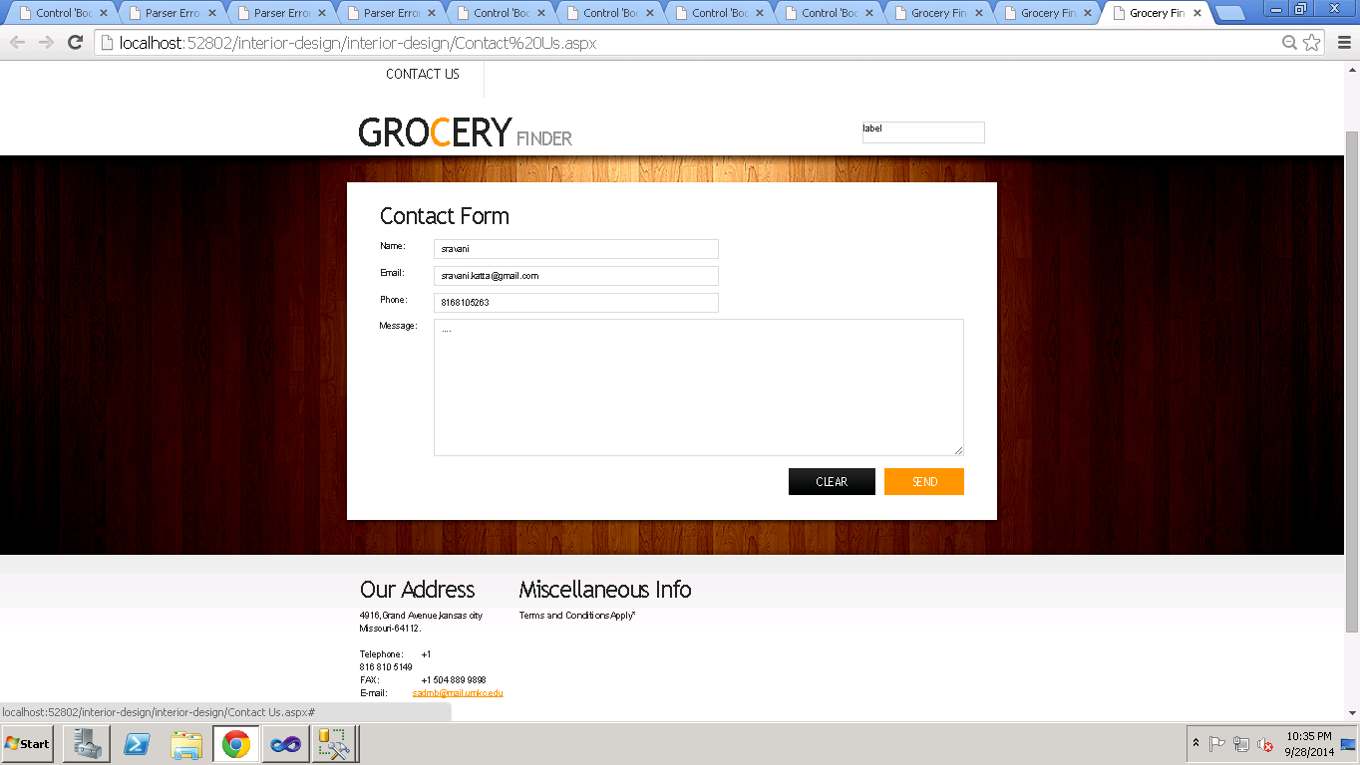

**6. Limitations:**

API’s are not readily available for free.

**7. References:**

* [**https://www.google.com/**](https://www.google.com/)
* [**http://www.walmart.com/**](http://www.walmart.com/)
* [**https://www.aldi.us/**](https://www.aldi.us/)
* [**http://www.costco.com/**](http://www.costco.com/)
* [**http://stackoverflow.com/**](http://stackoverflow.com/)
* [**http://forums.asp.net/**](http://forums.asp.net/)

**CHALLENGE 2**

**1. Design:**

**a.Architecture Diagram:**

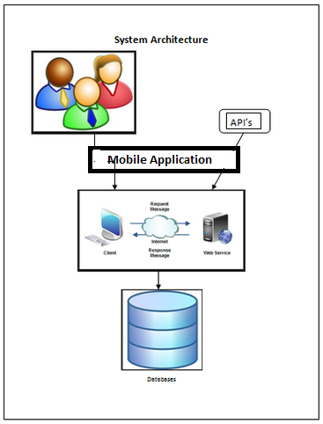

**Class Diagram:**

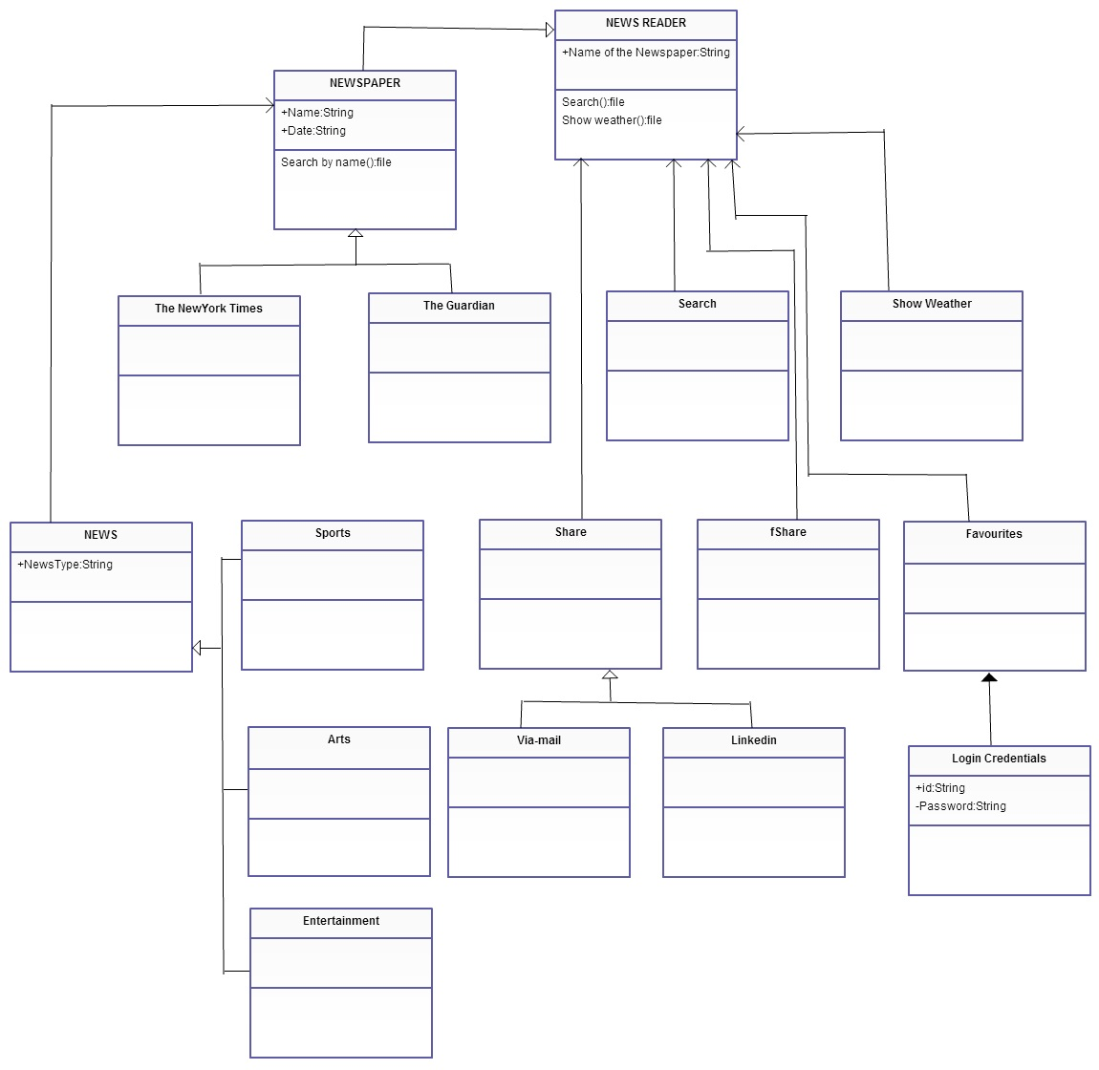

**2. Features Implemented:**

* Home Page
* Services Page
* News Articles
* Share options
* Favorites Page
* User Authentication Page
* Weather Services Page
* Search Page

**3. Tools Used:**

1. **Database:**

We have used two newspapers “Guardian” and “NY-Times” so these databases are used in our project. Reader can share the article in face book or e-mail etc by logging in to his account using the face book database.

1. **Mobile User Interface:** Android
2. **Tools:** Android Development Kit, Eclpise

**3. Screenshots of News Reader:**

This is the home page of our application “News Reader”.



Home page of News Reader

Our application enables users have the news up to date and makes him aware of the environment around him.

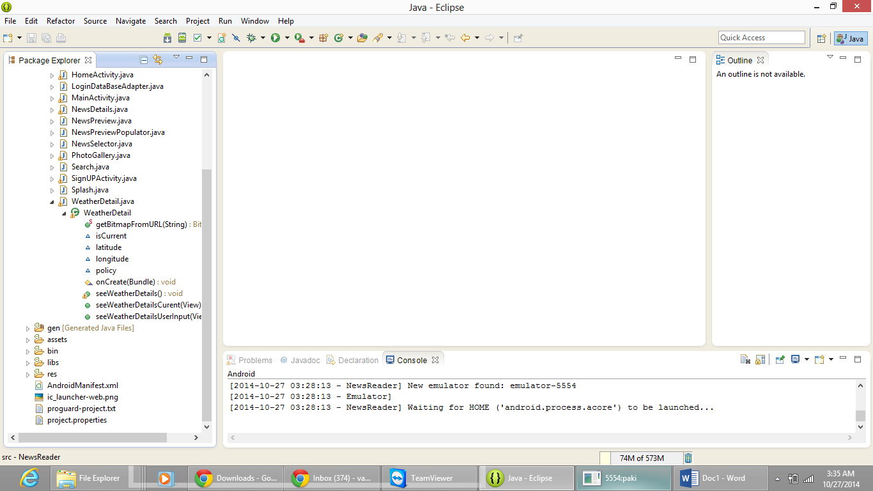

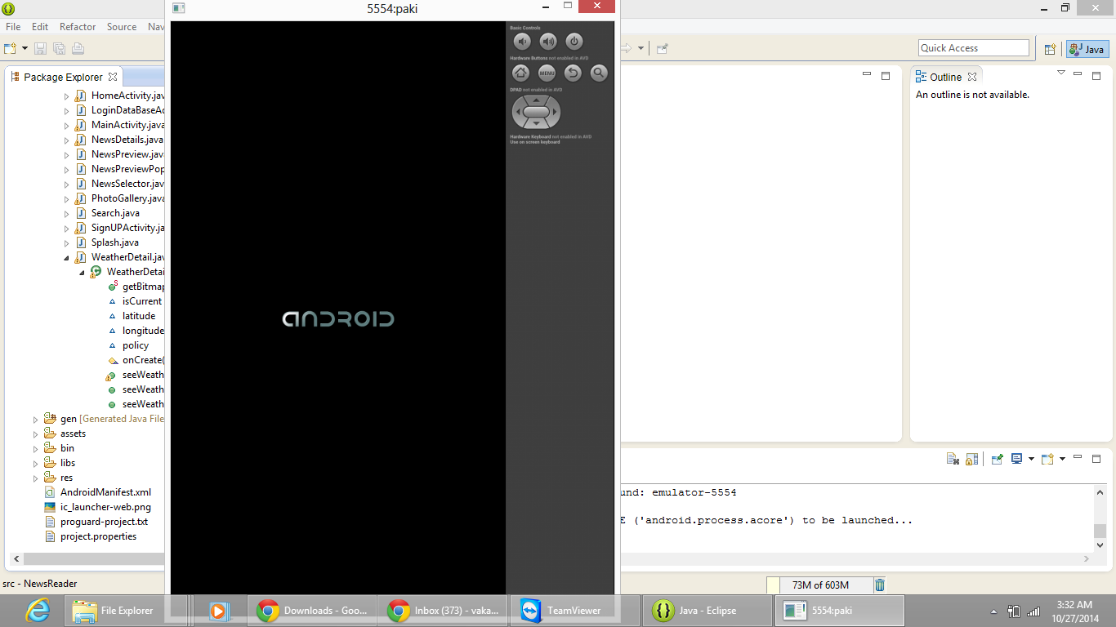

We have used the android development kit and using the emulator we tried to develop our app and the above shown screen shots explains the same.

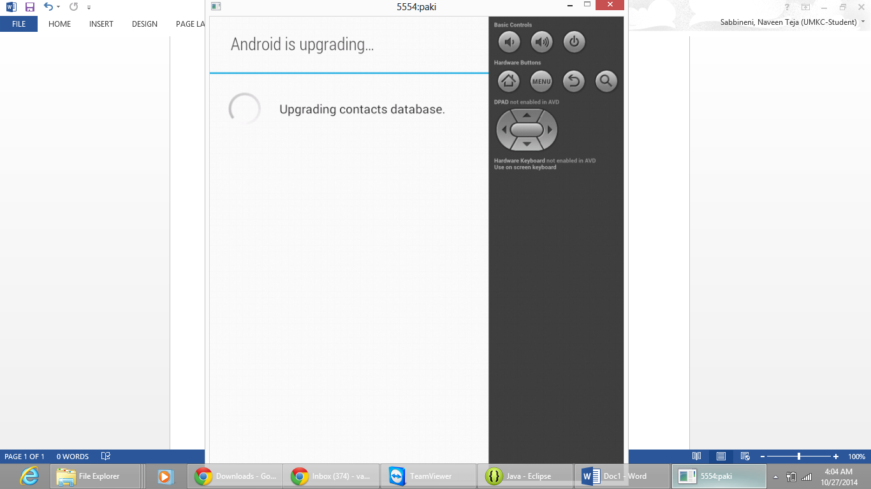

We have two papers in our application so that the reader can select the paper of his choice the screen shot of that is shown below.

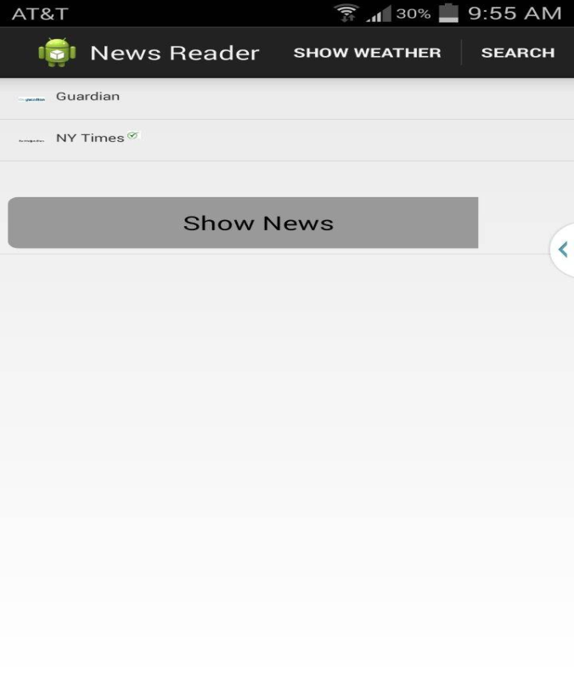

The above screen shot shows two papers one with the name Guardian and the other is NY Times from which the reader selects the paper of his choice. Then he clicks the button “Show News” to fetch the results of his choice.

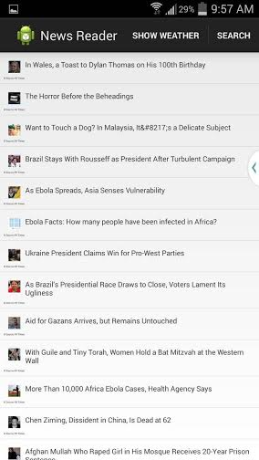

The above screen shot shows that the news with the headlines is enlisted from the particular paper. The reader can select a particular topic based on his interest from all the list of news articles.

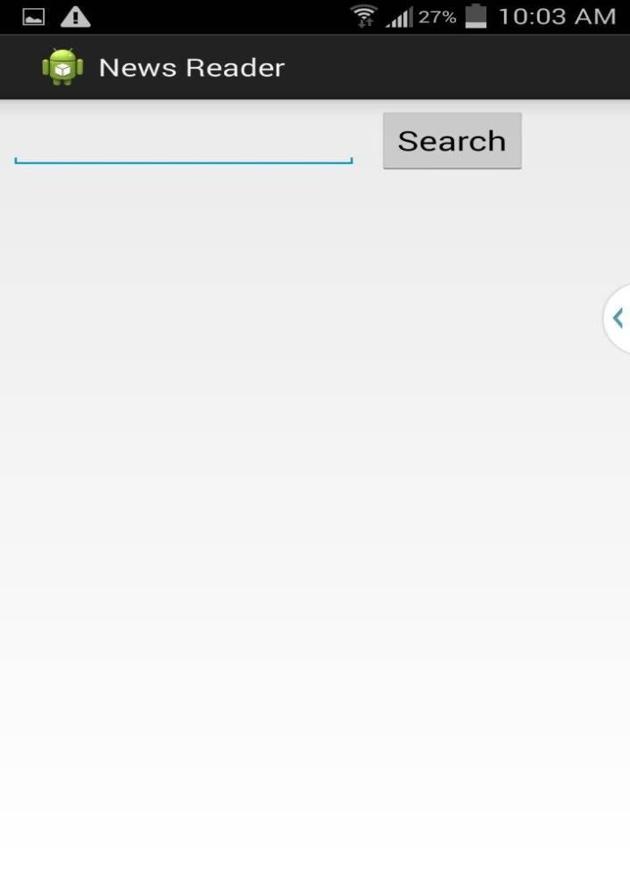

We have the search tool too from which we can type the article whatever we are looking for and can have the news regarding that particular topic. The above screen shot shows the same explanation

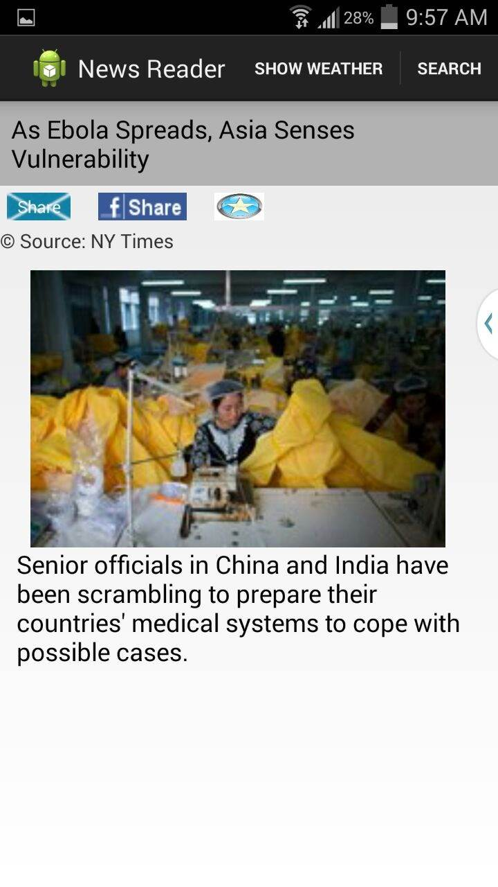

By selecting a particular topic say if the reader has selected the topic “As Ebola spreads, Asia Senses Vulnerability” the news regarding the particular topic with the images concerned are being displayed providing all the news listed in the newspaper about that particular topic.

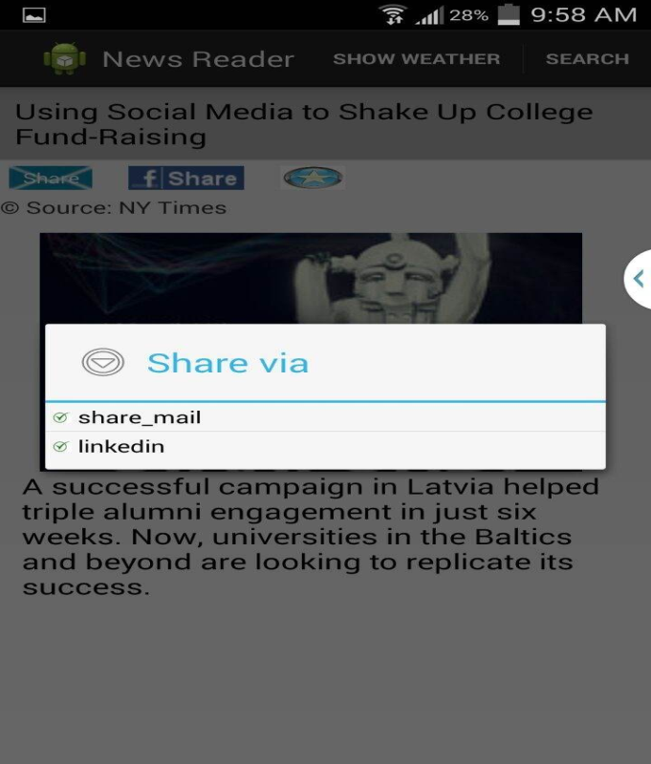

We have features like “Share” which enables reader to have an option of sharing the article what he had read to his peers using the email, face book, LinkedIn etc.

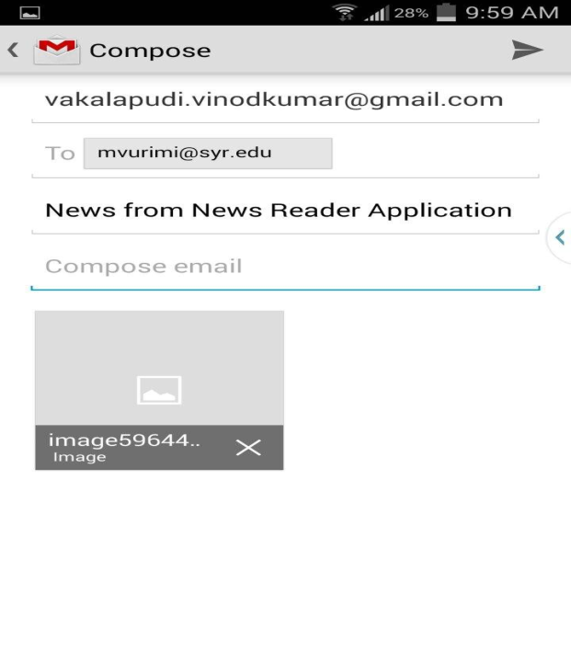

Screen shot which shows the share of an article using Gmail

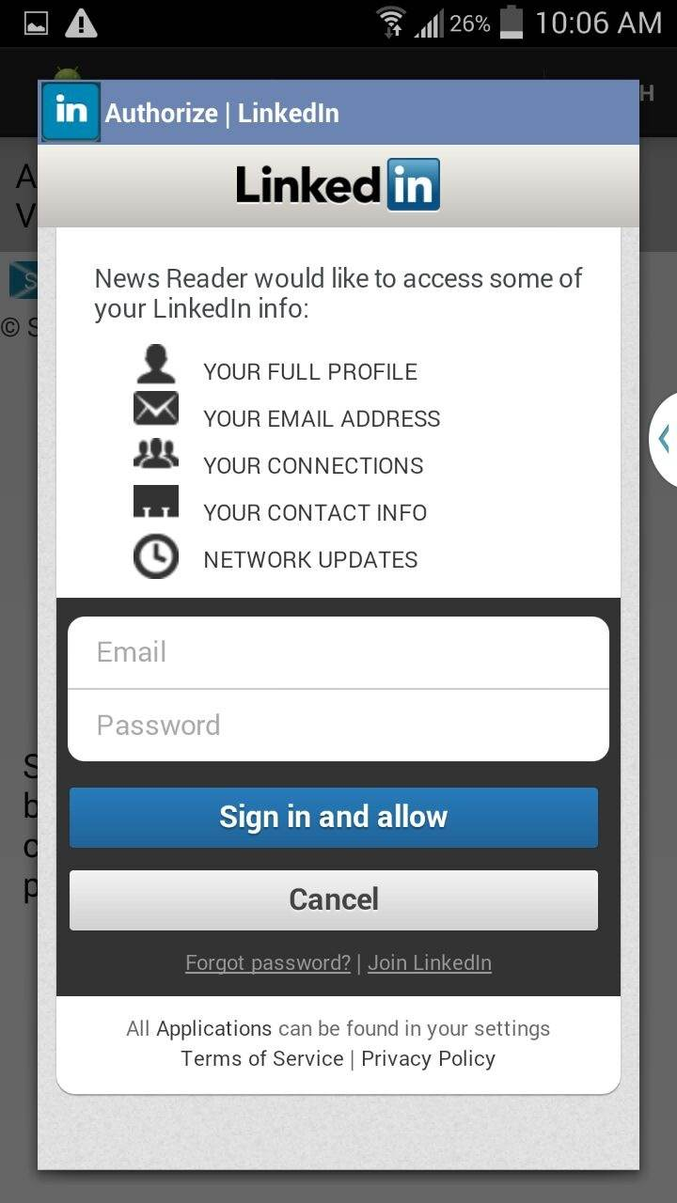

Screen shot which shows the share of an article using LinkedIn



Screen shot which shows the share of an article using Face book.

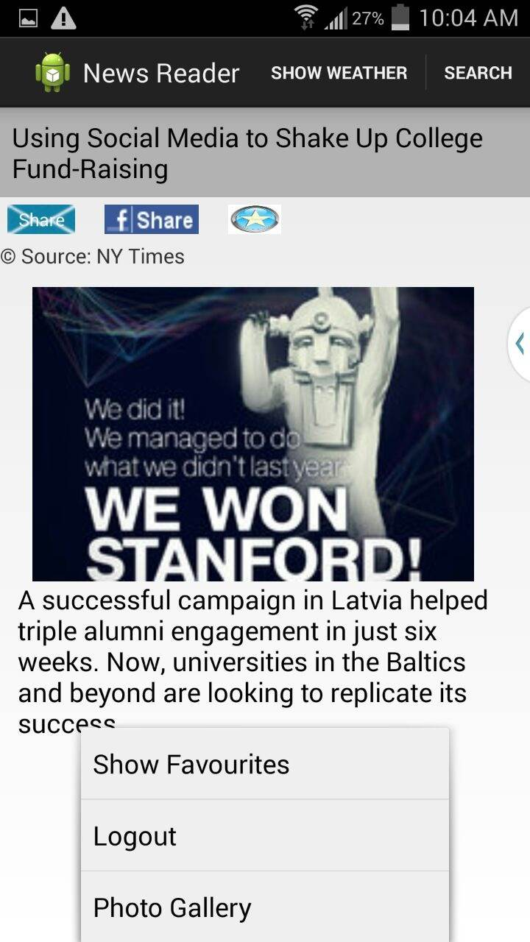

We will be providing the feature like Show Favorites, Logout and Photo Gallery options too in the drop down menu using them we can have the history of all the articles that are being viewed by us as recorded and we can make a particular article favorite and can review it later whenever required.

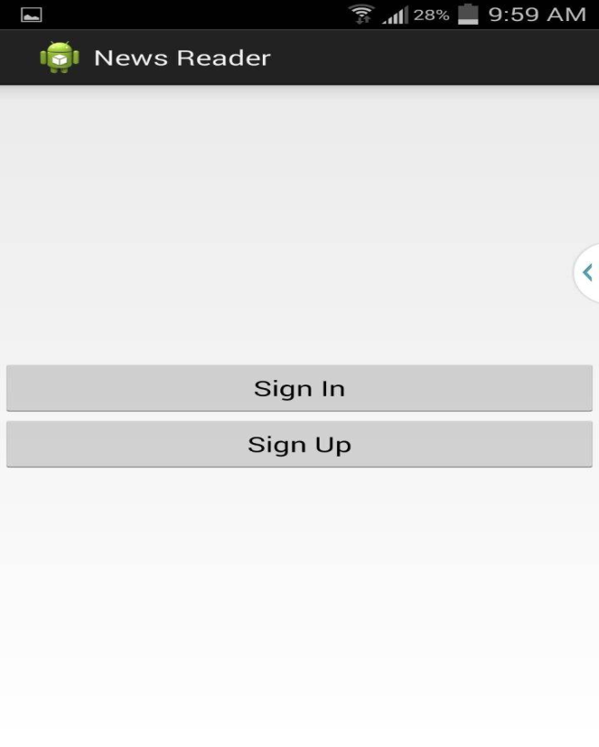

This can be done by the user signup by giving his credentials to our News Reader application.

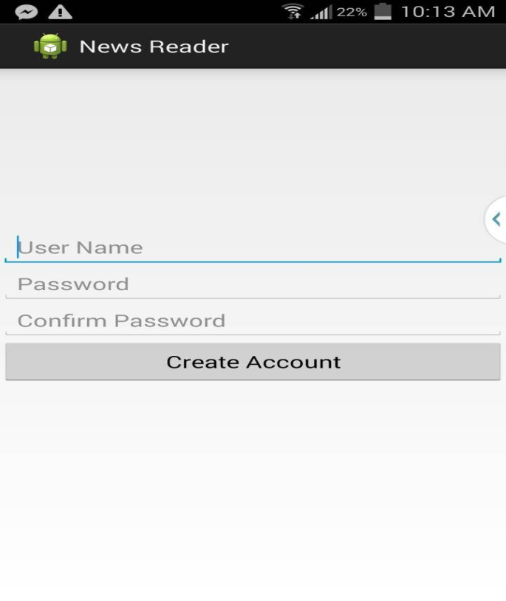

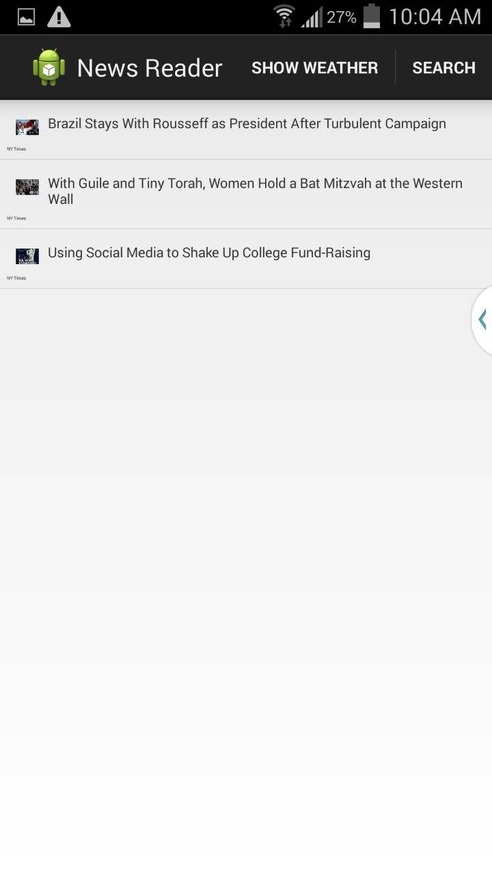

Screen Shot which shows the favorite News Articles

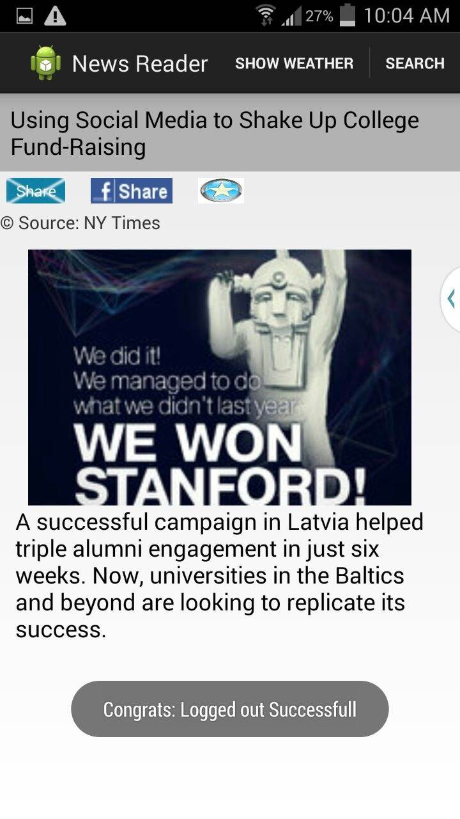

Screen shot shows that the reader has logged out

The User after having read the news and sharing, adding the articles to his favorites can logout from his account and a pop-up message is being displayed as “Congrats: Logged out Succesfull”.

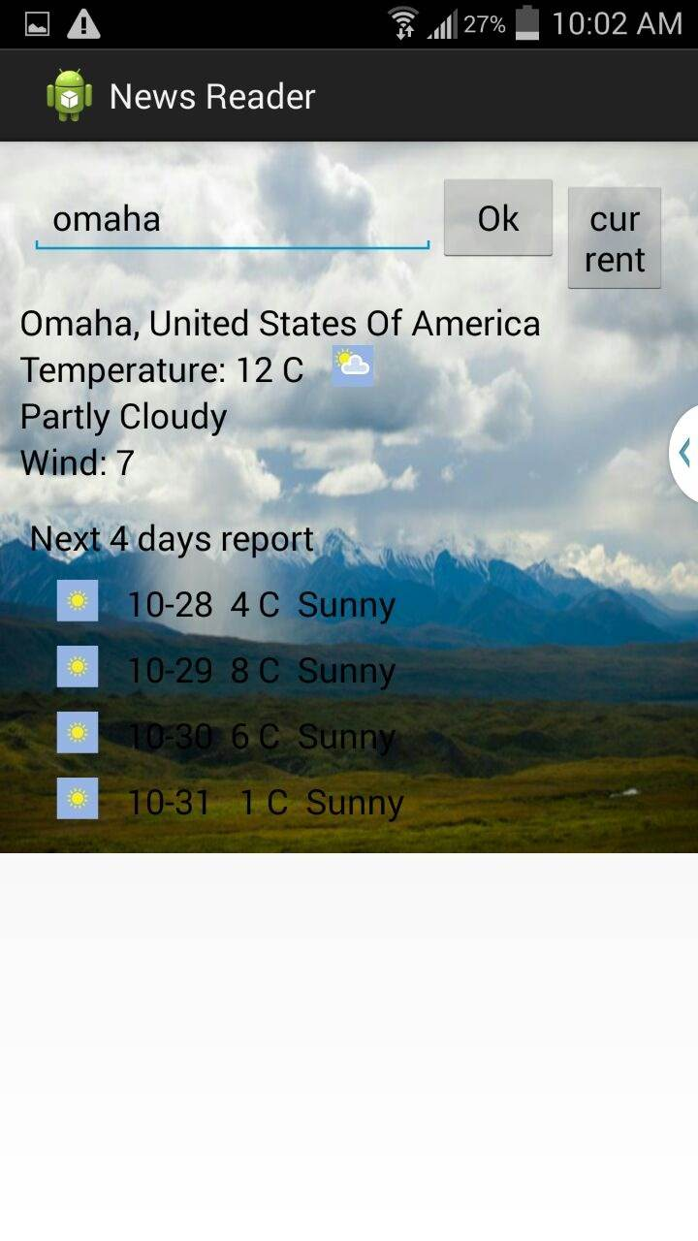

Screen shot showing the weather conditions of a particular place “Omaha”

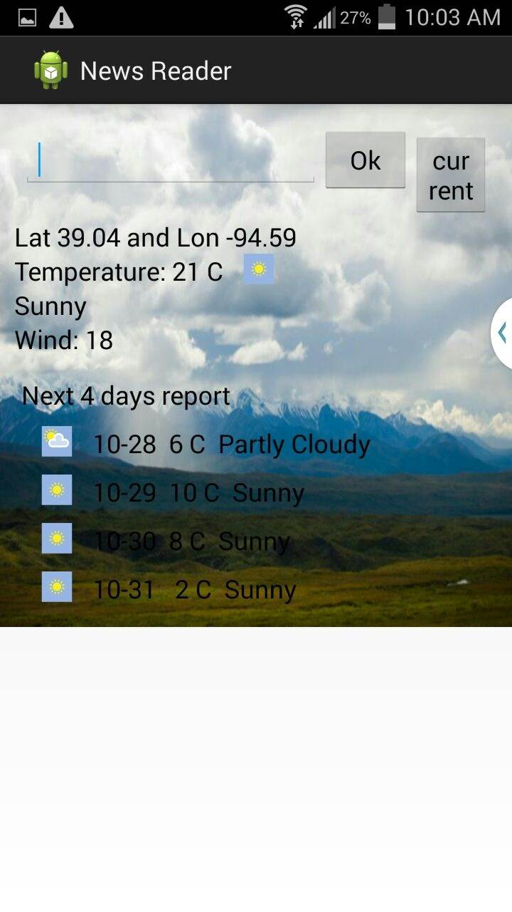

Screen shot displays the weather Conditions of the current location

We have implemented one more feature of displaying the weather. Users can know the temperature of a place where he resides and the place of his interest.

**5. Limitations:**

Our project is confined to two papers only. Due to time constraints it is not implemented with more papers.

**6. Github URL:**

https://github.com/syamalareddy/challenge2.git

**7. References:**

* <http://www3.nd.edu/~cpoellab/teaching/cse40814/android_tutorial.pdf>
* <http://www.nytimes.com/pages/todayspaper/>
* <http://www.theguardian.com/us>
* <http://www.weather.com/>

**PROJECT INCREMENT 2**

**Introduction:**

Preparation is an important task and is highly in demand for the students in the case of selecting the universities. To qualify the gre and toefl exams, you need to know each and every detail about the exam, logon to their websites and surf about them. Also, it will be difficult to adapt to different patterns and designs as each website has their own in built design. To avoid these problems, our project acts as a single stop where in user can find different websites in one place with a common user interface (UI). This project provides feasibility to have sample exams and model papers all in a single application both through mobile and web applications.

**Overall goal:**

Our project gives clear idea about many things that are necessary for a student at the time of choosing a school to pursue his degree and also after attending the school. We have many features in our project which provides many answers to various types of questions that were really necessary and helpful to the students at the selection process of a school. We divide various questions into some groups.

Example: Admission Procedure is a group in which it can answer many questions like

1. What are the steps to be followed to apply to the school?

Ans: student should have gre, toefl/ ielts score card, transcripts, sop, lor etc.

2. What are the required scores that are mandatory to apply?

Ans: gre 300+ particularly having quant score more than 160 and Toefl with a score of 100 minimum or ielts with minimum of 6.5

3. Is the school accepts ielts score less than 6.5?

Ans: Yes, the school will also accepts the score of 6 but student must have to attend a test i.e., ALI.

Once the student decides his school then he will be provided with model test papers of both the gre and toefl/ielts exams with all the sections covered in it.

Example: We provide sections like quant, verbal, analytical writing under gre exam and sections like speaking, listening, writing and reading under toefl exam.

**Proposed System:**

**Functional Requirements (Prioritized):**

* Students can register with their details, login and then update their profile if required.
* Students can choose the required exam and under that the required category in the website.
* Navigation and route maps are provided to the students about the universities.
* Statistics are provided to the students at different categories of exams like gre and toefl.

**Functional Requirements:**

* Our online service will be student friendly and easy to use.
* available on every day i.e., 24*7
* Loading our web application is fast as it uses very less bandwidth.

**Implementation Status Report:**

**Work Completed till 2nd Increment:**

In second increment, along with the 1st increment development we designed web services. We have also created web services for the registration and login of user.

**Detail Design of Web Services:**

The web services which we developed were:

1) Login web service

2) Topics find

Login web services have the following methods:

1) Student Login check

2) Student Profile update

3) Student Profile retrieval

4) Student Registration

**Implementation of Services:**

Below services developed as part of this increment is:

* Contact us service

**Screenshots of Web Application:**

**Home Page:**



**Login Page:**



**Student Profile:**

After login the student is redirected to set of options of editing his student details and also to choose among list of available services as below.





**Screenshots of our android application:**

When the user clicks the gre icon it redirects to a page where all the information regarding gre is given.

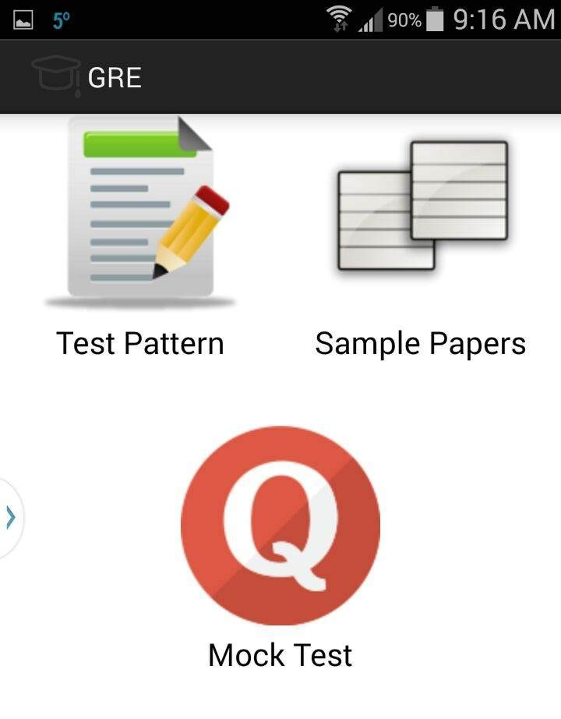

The above screenshot shows the icons like test pattern, sample papers and mock test where the test pattern gives the clear idea about the pattern of the test, sample pattern gives some example questions or problems from the test and the users are provided with the model papers too.

**GRE Test Pattern:**

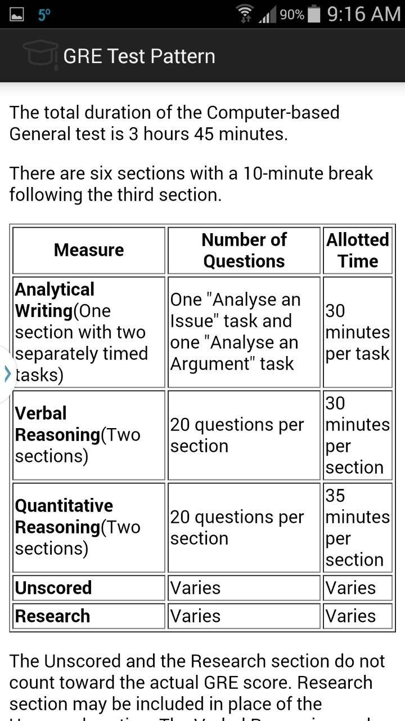

The above screenshot generally gives the description about the pattern of the exam say it gives the details about the sections in the exam even with time allotted for particular section and the weight age of the questions and all.

**Sample Papers:**

The below screenshot shows the sample papers icon with verbal reasoning, quantitative analysis and analytical writing.

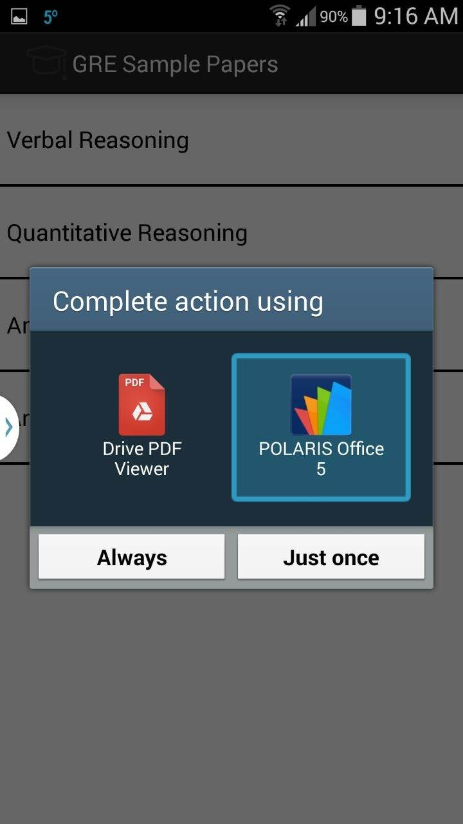

The below shown screenshot gives the sample model paper.

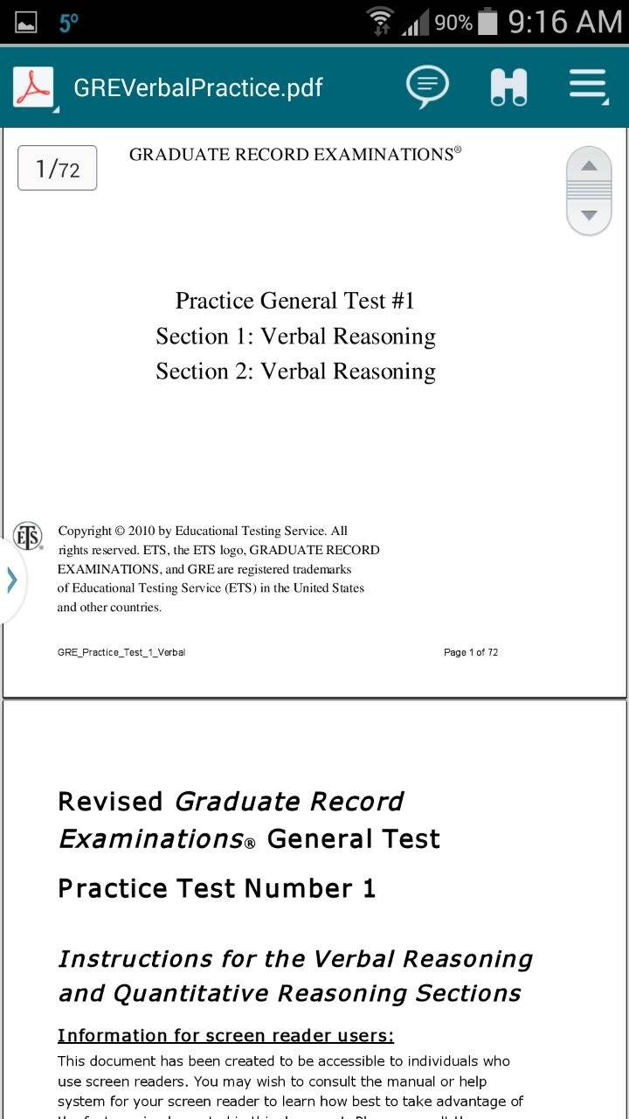

**Mock Test:**

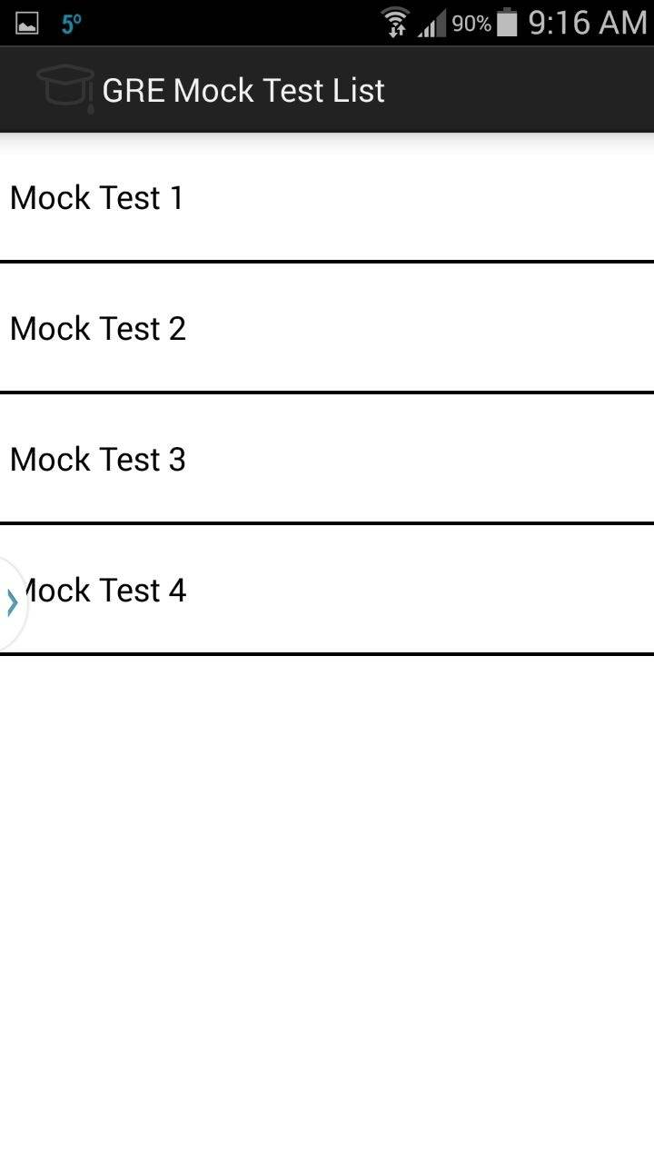

This shows the number of mock tests available in our application where users can have the sample test free of cost and can improve their skills. So when the user clicks the mock test then he is redirected to the corresponding test paper.

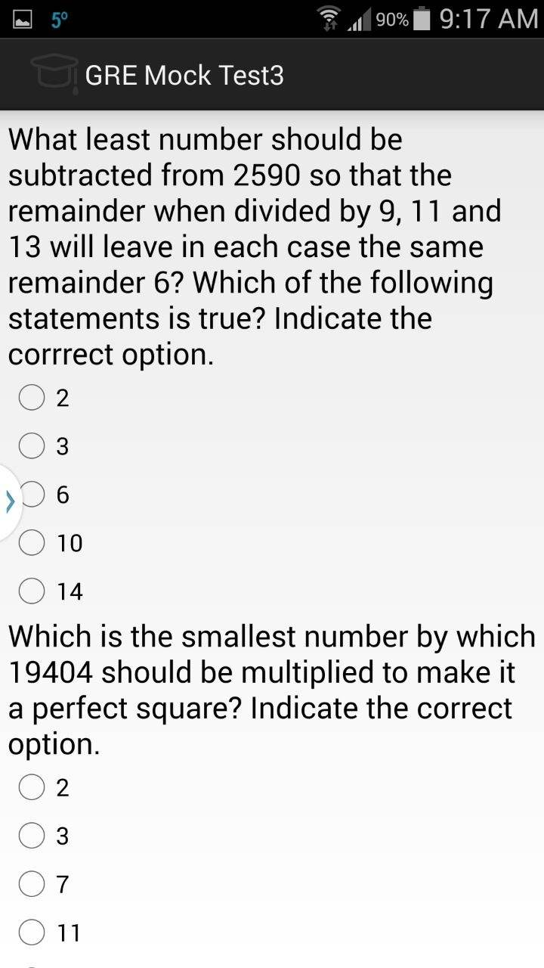

**TOEFL:**

The below screenshot shows the icons like test pattern, sample papers and mock test where the test pattern gives the clear idea about the pattern of the test, sample pattern gives some example questions or problems from the test and the users are provided with the model papers too.

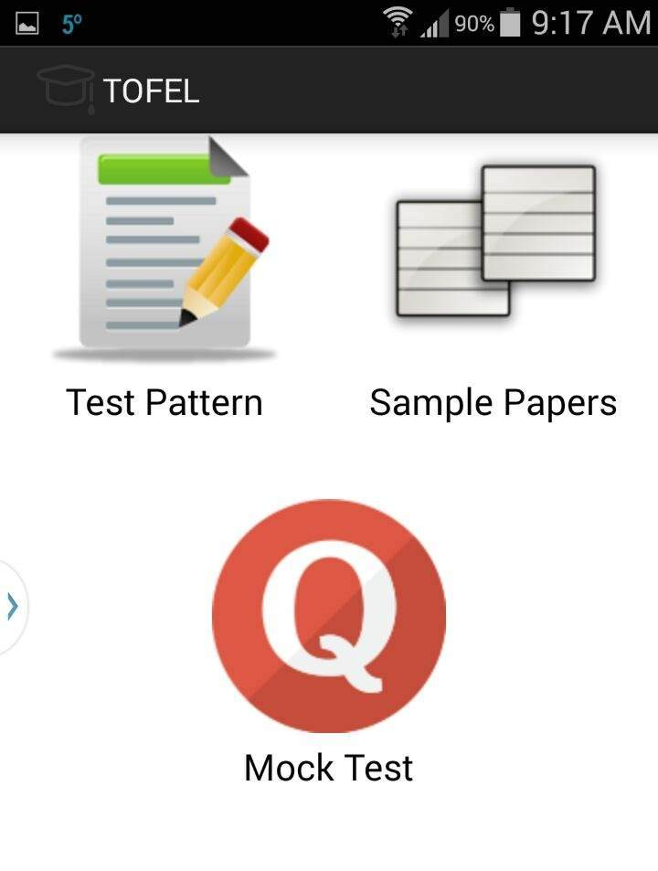

**Test Pattern:**

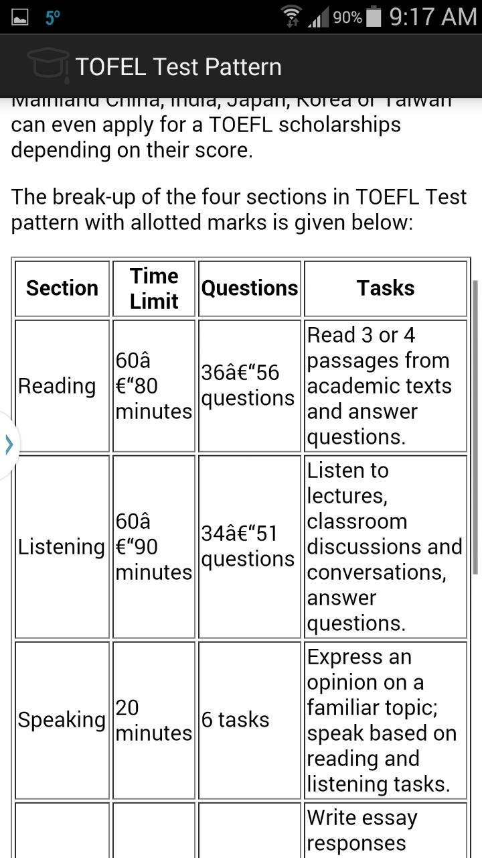

The above shown screenshot gives clear idea about the test pattern with the sections like reading, speaking, listening and writing and detailed idea about the tasks to be done under each section with the number of questions and the time allocated for each section.

**Sample papers:**

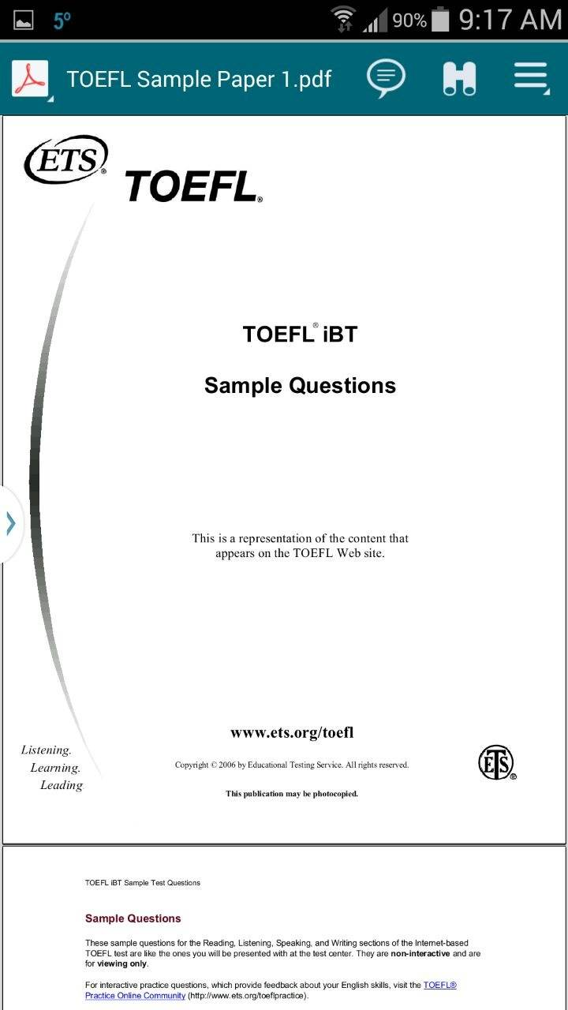

Above shown is the screenshot of sample paper.

**Mock test:**

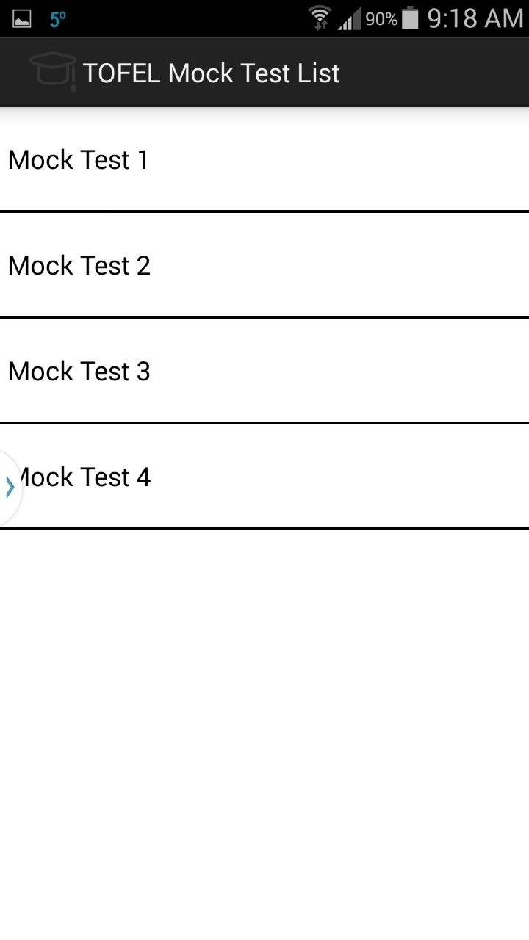

The above shown screen shot shows the number of model papers where users can view and practice all the sample mock test and enhance their skills and can assess their capability in each and every section.

**Work Completed As Part Of 2nd Increment:**

We implemented the web services in second increment and linked it to database.

**Responsibilities:**

|  |  |  |  |
| --- | --- | --- | --- |
| **S.No** | **Task** | **Person involved** | **Estimated Time** |
| 1. | Completed work regarding GRE and Toefl services | Syamala  Swathi  Vinod  Rayan | 20 hours |
| 2. | Created web services for login and registration of student | Swathi  Syamala  Vinod | 12 hours |
| 3. | Created web services for Different Topics retrieval, addition and update. | Swathi  Syamala  Rayan | 10 hours |
| 4. | Testing web services using Nunit testing | Swathi  Syamala  Rayan | 3 hours |
| 5. | Documentation work | Swathi  Syamala  Vinod | 3 hours |

**Work to be completed in 3rd increment:**

**Responsibilities:**

|  |  |  |
| --- | --- | --- |
| **Sl.No** | **Task** | **Person involved** |
| 1. | Student capability will be displayed on bar or pie chart | Syamala  Vinod  Swathi |
| 2. | Implementing the list of universities service | Syamala |
| 3. | Further enhancements to second increment will be implemented. | Swathi  Vinod |
| 4. | Logo images to be inserted to each and every admin. | Rayan |
| 6. | Android web pages will be designed | Vinod |
| 7. | Testing | Swathi  Syamala |
| 8. | Documentation | Syamala  Vinod  Swathi  Rayan |

**Scrumdo Screenshots:**

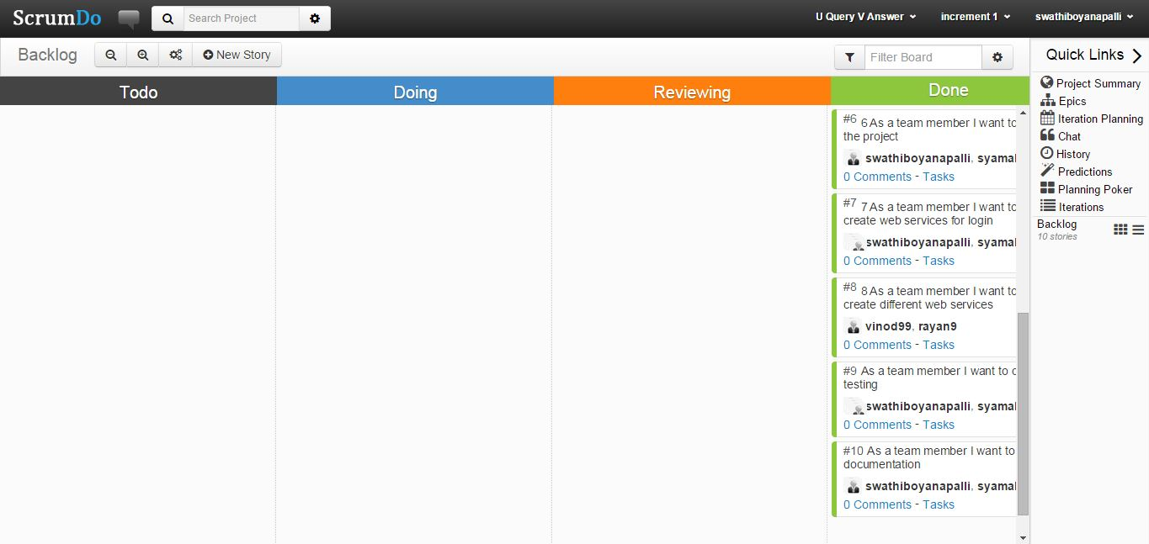

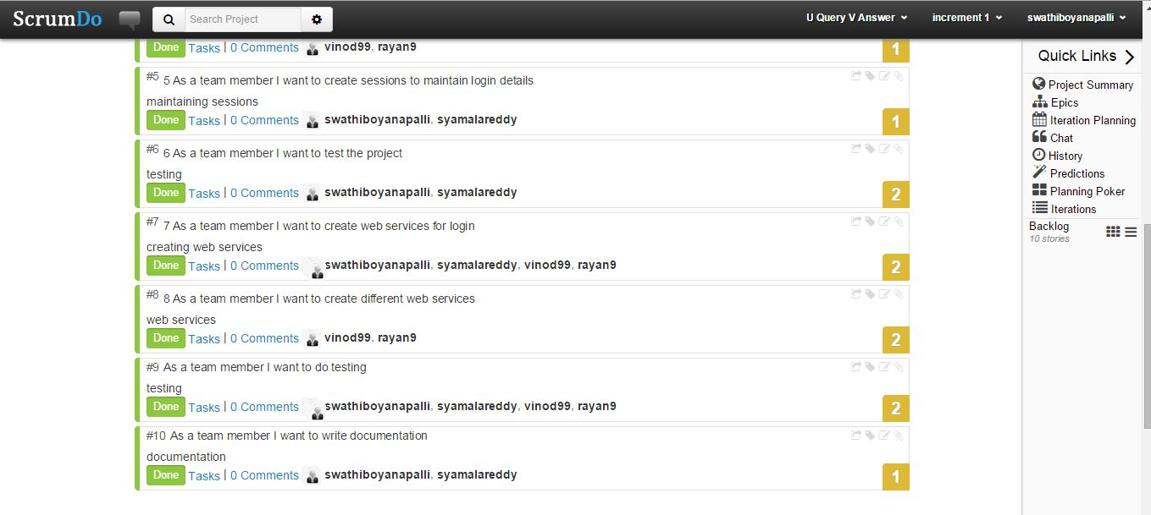

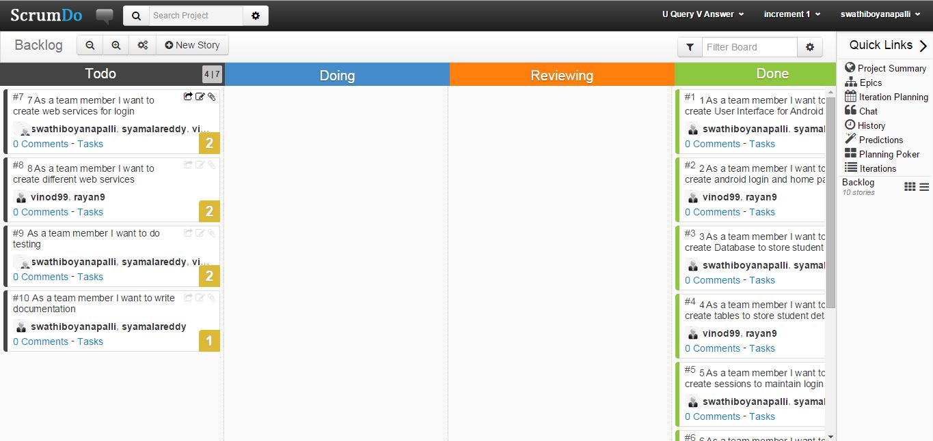

**CHALLENGE 3**

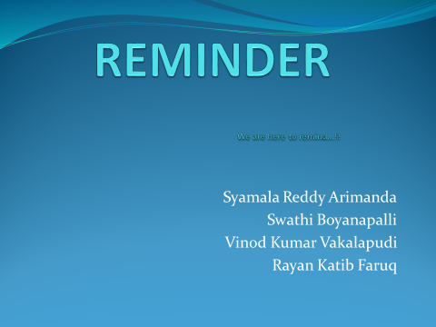 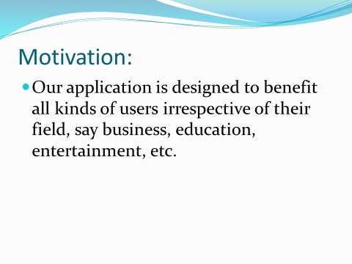 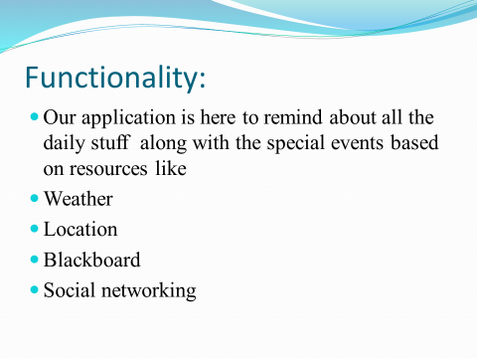 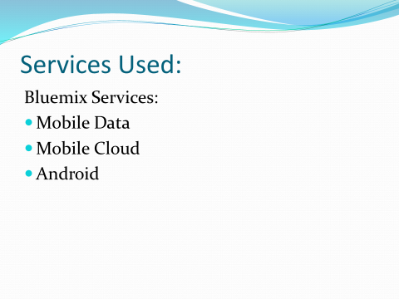 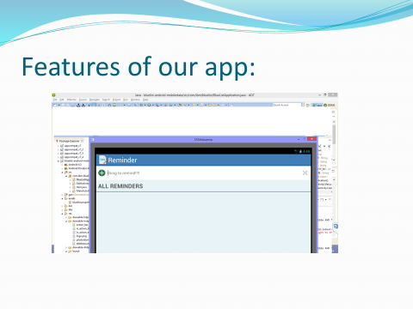 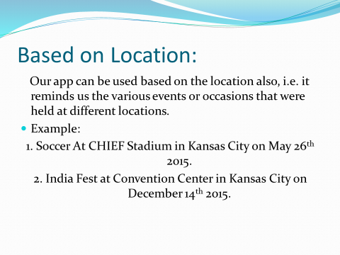 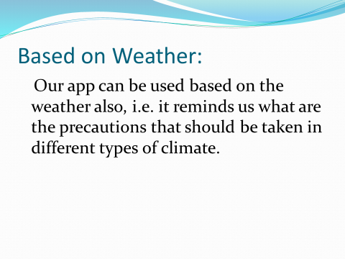 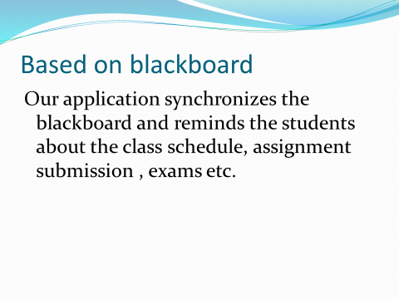 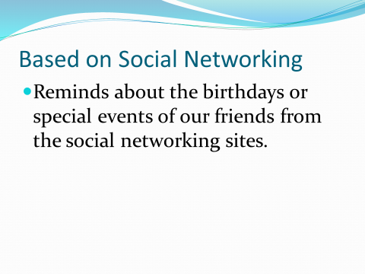 

**PROJECT INCREMENT 3**

**Introduction:**

Preparation is an important task and plays a key role for the students in the case of selecting the universities. To qualify the gre and toefl exams, you need to know each and every detail about the exam, logon to their websites and surf about them. Also, it will be difficult to adapt to different patterns and designs as each website has their own in built design. To avoid these problems, our project acts as a single stop where in user can find different websites in one place with a common user interface (UI). This project provides feasibility to have sample exams and model papers all in a single application both through mobile and web applications.

**Overall goal:**

Our project gives clear idea about many things that are necessary for a student at the time of choosing a school to pursue his degree and also after attending the school. We have many features in our project which provides many answers to various types of questions that were really necessary and helpful to the students at the selection process of a school. We divide various questions into some groups.

Example: Admission Procedure is a group in which it can answer many questions like

1. What are the steps to be followed to apply to the school?

Ans: student should have gre, toefl/ ielts score card, transcripts, sop, lor etc.

2. What are the required scores that are mandatory to apply?

Ans: gre 300+ particularly having quant score more than 160 and Toefl with a score of 100 minimum or ielts with minimum of 6.5

3. Is the school accepts ielts score less than 6.5?

Ans: Yes, the school will also accepts the score of 6 but student must have to attend a test i.e., ALI.

Once the student decides his school then he will be provided with model test papers of both the gre and toefl/ ielts exams with all the sections covered in it.

Example: We provide sections like quant, verbal, analytical writing under gre exam and sections like speaking, listening, writing and reading under toefl exam.

**Proposed System:**

**Functional Requirements (Prioritized):**

* Students can register with their details, login and then update their profile if required.
* Students can choose the required exam and under that the required category in the website.
* Statistics are provided to the students at different categories of exams like gre and toefl.

**Functional Requirements:**

* Our online service will be student friendly and easy to use.
* available on every day i.e., 24*7
* Loading our web application is fast as it uses very less bandwidth.

**Screenshots:**

**Home Page:**

This is our home page where we have icons for gre, toefl and the list of universities and we have one more service as contact us page as shown below.

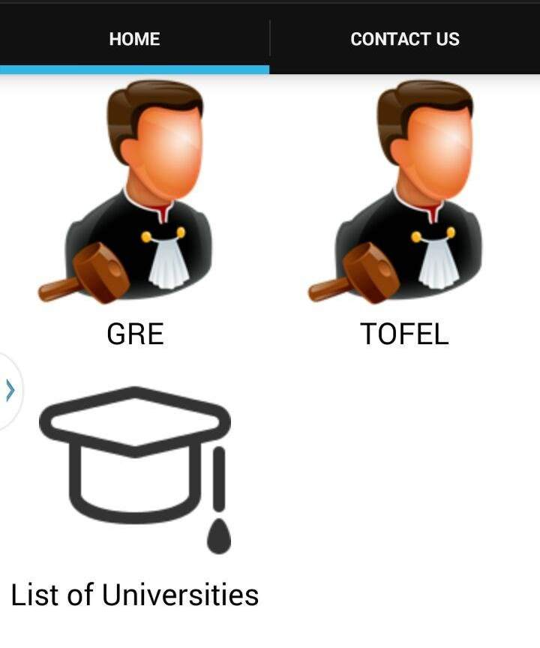

When the user clicks the gre icon it redirects to a page where all the information regarding gre is given.



The above screenshot shows the icons like test pattern, sample papers and mock test where the test pattern gives the clear idea about the pattern of the test, sample pattern gives some example questions or problems from the test and the users are provided with the model papers too.

**GRE Test Pattern:**



The above screenshot generally gives the description about the pattern of the exam say it gives the details about the sections in the exam even with time allotted for particular section and the weightage of the questions and all.

**Sample Papers:**

The below screen shot shows the sample papers icon with verbal reasoning, quantitative analysis and analytical writing.



The below shown screen shot gives the sample model paper.



**Mock Test:**



This shows the number of mock tests available in our application where users can have the sample test free of cost and can improve their skills. So when the user clicks the mock test then he is redirected to the corresponding test paper.



**TOEFL:**

The below screenshot shows the icons like test pattern, sample papers and mock test where the test pattern gives the clear idea about the pattern of the test, sample pattern gives some example questions or problems from the test and the users are provided with the model papers too.



**Test Pattern:**



The above shown screenshot gives clear idea about the test pattern with the sections like reading, speaking, listening and writing and detailed idea about the tasks to be done under each section with the number of questions and the time allocated for each section.

**Sample papers:**



Above shown is the screenshot of sample paper.

**Mock test:**



The above shown screen shot shows the number of model papers where users can view and practice all the sample mock test and enhance their skills and can assess their capability in each and every section.

**Universities:**

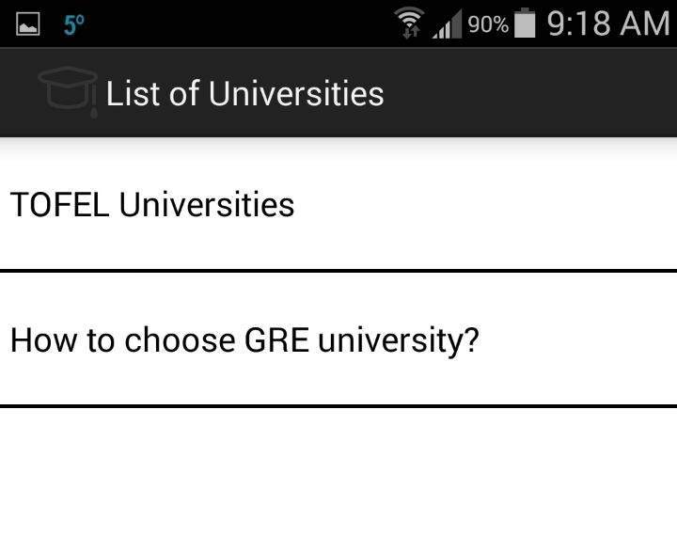

Accessing the score from the model test papers he may calculate the corresponding scores and can have an idea of the university depending upon his credentials and can even aim for the universities of his choice by improving the performance in each section.

**Universities based on gre score:**

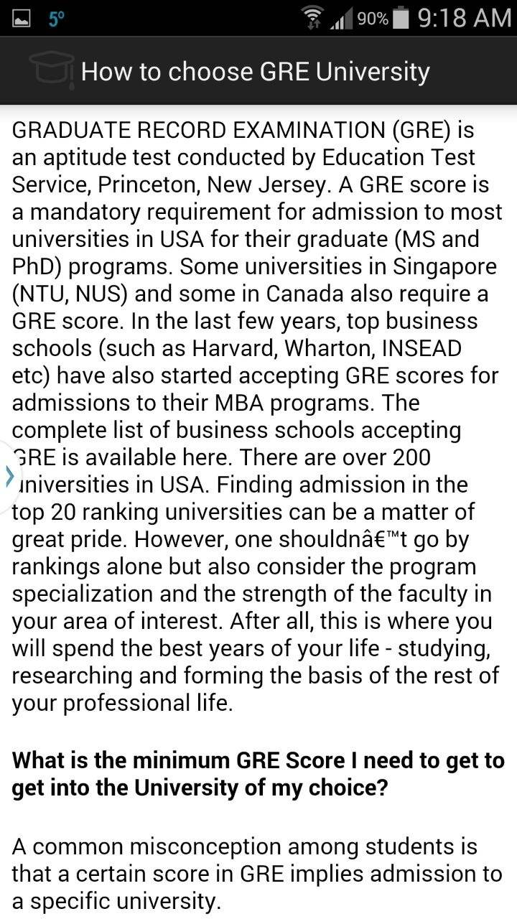

The above screenshot shows the information about the universities and the list of universities depending on the score obtained in the mock tests student may asses their universities and may apply for them.

**Universities based on Toefl score:**

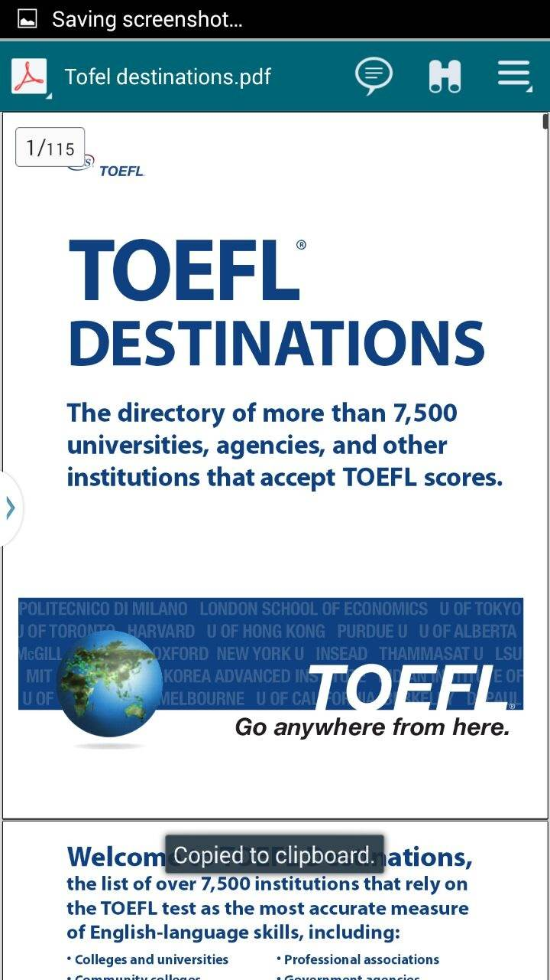

The above shown screenshot gives clear idea about the list of universities based on the Toefl score so that the user can have clear idea about the score requirements of the particular university.

**Contact Us:**

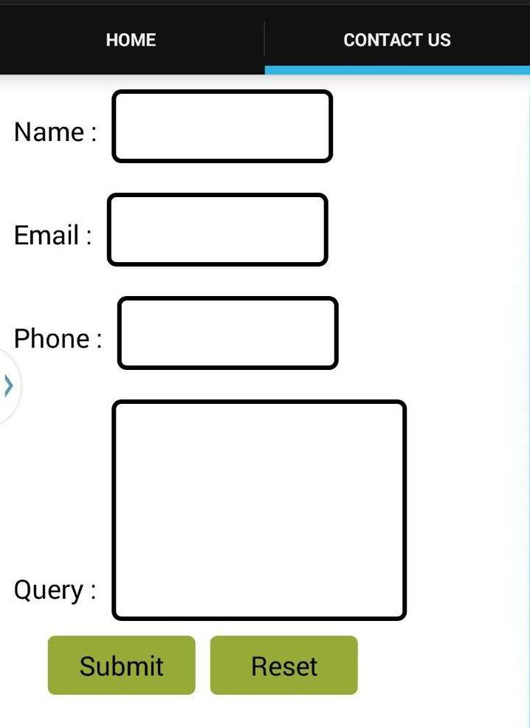

The above screenshot shows the contact us page where the user can have his query sent to us by giving some normal details like name, email and phone number and clicks the submit button.

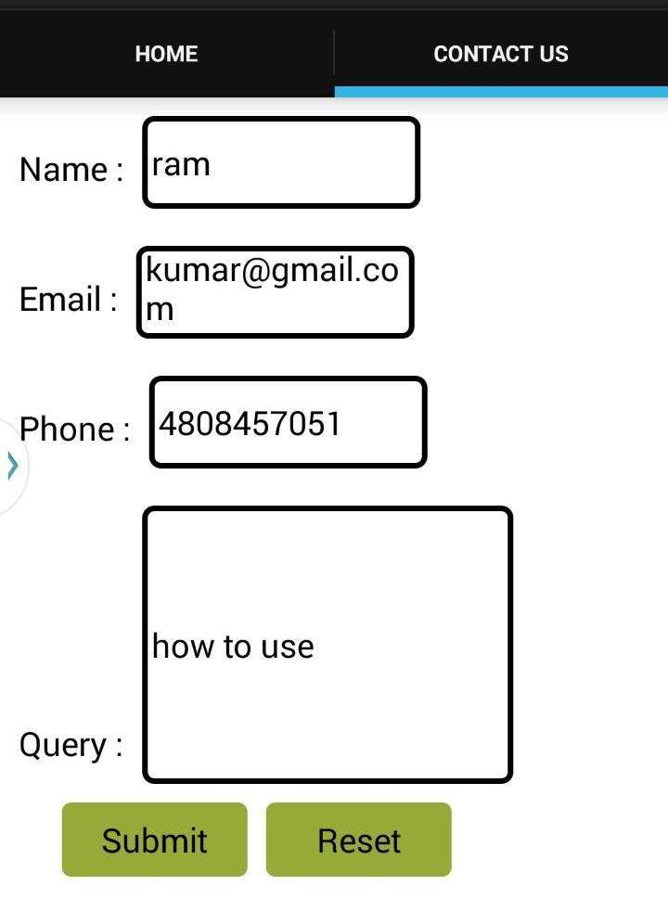

The above shown screenshot is the example of the contact form and gives clear idea about this service.

**Roles and Responsibilities:**

|  |  |  |
| --- | --- | --- |
| **Sl.No** | **Task** | **Person involved** |
| 1. | Android web pages are designed | Syamala  Vinod  Swathi |
| 2. | Further enhancements to second increment will be implemented. | Vinod  Rayan |
| 3. | Logo images to be inserted to each and every admin. | Rayan |
| 4. | Testing | Swathi  Syamala |
| 5. | Documentation | Syamala  Vinod  Swathi  Rayan |

**Screenshots of Scrumdo:**

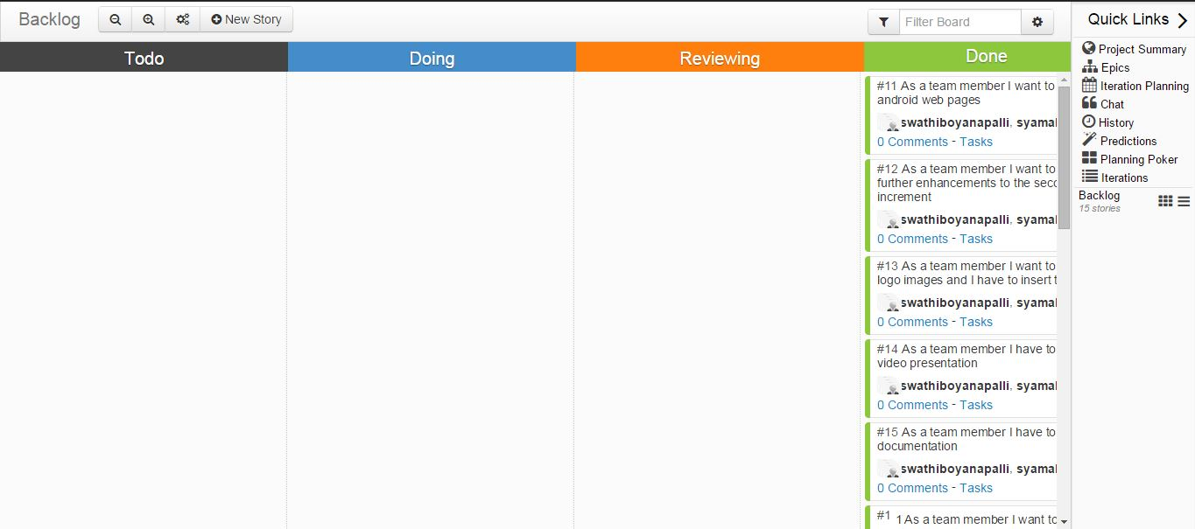

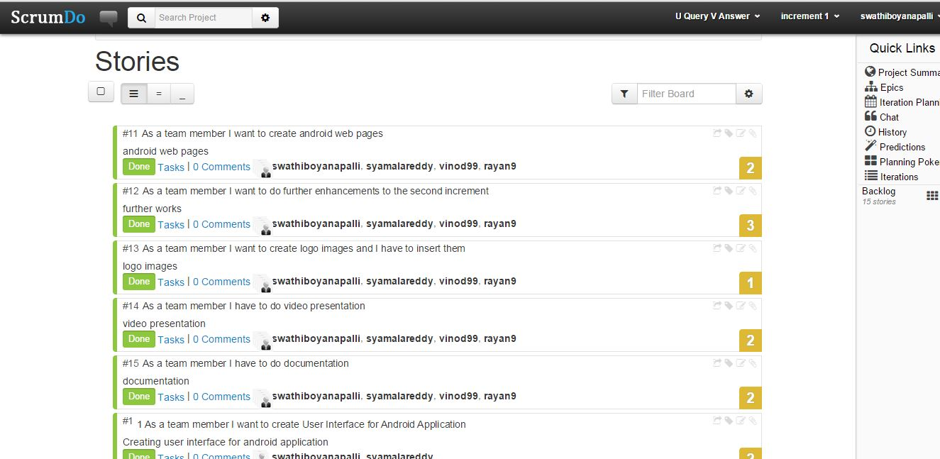

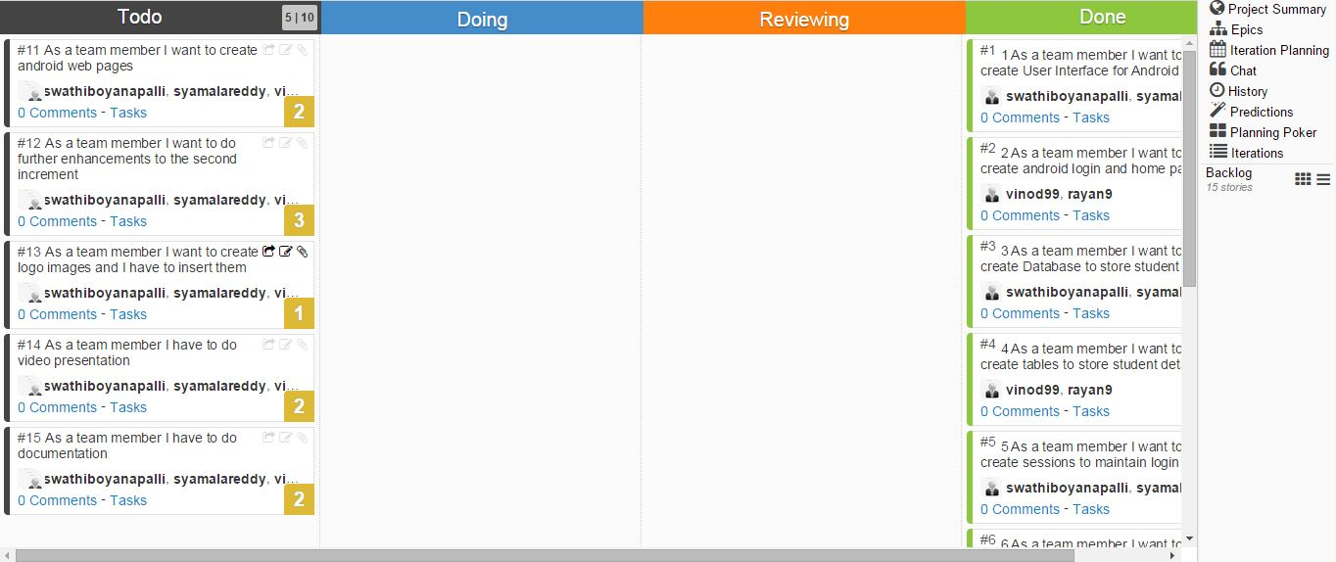

**FINAL PROJECT EVALUATION**

As part of our project completion we would like to evaluate our system. Our main aim in taking up this project was to provide a single platform to the students in accessing different types of competitive examination model papers like GRE, TOEFL, and enable students/users to easily navigate through all the services and choose amongst them. We were successful in implementing all of the services we initially gave a thought to.

Before we got into the development phase we got a clear picture about our design model by drawing UML diagrams for our system. This gave us a complete overview on how we need to proceed in each phase. We have used agile process model in developing our project. One great thing about picking up agile model is that every person involved in the project gets to work in it learning to accomplish tasks in scheduled time.

One thing we should always have in mind is to maintain a clear cutting picture of how the output of each increment should be and design plans accordingly. Also in our future projects we would like to follow agile process model. As we followed this model and we had done each increment within a scheduled timeline, we never faced a problem. Everyone got involved in designing our project and so we were able to maintain timelines and deploy each increment as scheduled.

**PRESENTATION MATERIALS**

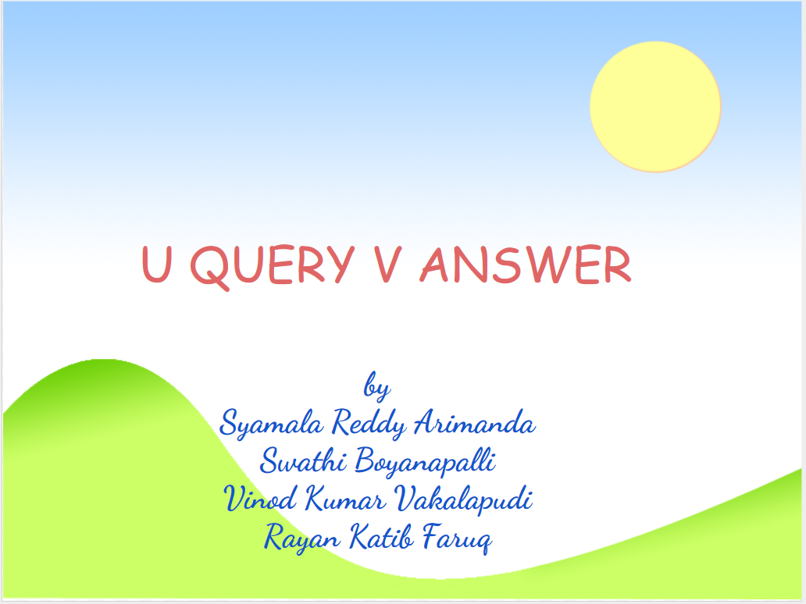



The main idea of our project is to have the GRE preparation material,Toefl preparation material and list of universities provided in a single application and to provide clear analysis of the test pattern and materail.

